STRATEGIC MANAGEMENT PLAN
2013 TO 2025
PHONG NHA - KE BANG NATIONAL PARK
The Natural World Heritage Site

Quang Binh province - October, 2012

QUANG BINH PROVINCIAL PEOPLE’S COMMITTEE  No: 808/QĐ-UBND | SOCIALIST REPUBLIC OF VIETNAM  Independence – Freedom - Happiness  Quang Binh, 09 April 2013

DECISION
Approval for the Strategic Management Plan 2013-2025 for Phong Nha Ke Bang National Park

CHAIRMAN OF QUANG BINH PROVINCIAL PEOPLE’S COMMITTEE

Pursuant to the Law on Organizing People's Council and People's Committee
Pursuant to the Law on Forest Protection and Development dated 26 November 2003;
Pursuant to the Decree Nº 23/2006/ND-CP dated 03 March 2006 by the Government of Vietnam enforcing the Law on Forest Protection and Development;
Pursuant to the Decree Nº 117/2010/ND-CP dated 24 December 2010 by the Government of Vietnam on organization and management of special use forest system;
Pursuant to the Decision Nº186/2006/QĐ-TTg dated 14 August 2006 by the Prime Minister regulating the forest management regulations;
Pursuant to the International Convention on World Natural and Cultural Heritage Sites and Operational Guidelines for implementing the International Convention on World Heritage by UNESCO’s World Heritage Center dated November 2011;
Pursuant to the Decision Nº 18/2007/QD-UBND dated 16 August 2007 by Quang Binh Provincial People’s Committee regulating the management regulations of Phong Nha Ke Bang National Park;
Pursuant to the Decision Nº 36/2012-UBND dated 28 December 2012 by Quang Binh Provincial People’s Committee regulating functions, mandates, rights and organizational structure of Phong Nha Ke Bang National Park;
Pursuant to the Decision Nº 263/QD-UBND dated 14 February 2012 by Quang Binh Provincial People’s Committee approving the Annual Work-plan and Budget Plan 2012 for KfW Component, Nature Conservation and Sustainable Natural Resources Management in Phong Nha Ke Bang National Park Region Project;
At the request of the Department of Agriculture and Rural Development in the Decision Nº 369/SNN-KL dated 22 March 2013,

HEREBY DECIDES

Article 1. Approve the Strategic Management Plan 2013 – 2025 for Phong Nha Ke Bang National Park with the basic content as follows:
1. Name of plan: Strategic Management Plan 2013 – 2025 for Phong Nha Ke Bang National Park, World Heritage Site
2. Objectives: Provide foundations for management of Phong Nha Ke Bang National Park and its buffer-zone in theory and guidelines for development of management prescriptions in accordance with the World Heritage Convention and Operational Guideline for implementation of this Convention.
3. Introduction on the Strategic Management Plan
- Purpose of the Strategic Management Plan
- Preparation and planning process
- World heritage background
- Ownership and control
- World Heritage Management Obligations
- World Heritage Values
- Other Heritage Values
- Management Background and Regional Setting
- Threats and Challenges
- Necessity of management planning
4. Management strategies
a. Overall management objectives
b. Main issues
- Protecting geo-diversity
- Conserving biodiversity
- Protecting historical and cultural values
- Protecting and enhancing integrity
- Appropriate presentation of heritage and tourism management
- Addressing livelihood issues
- Developing capacity and supporting management

Article 2. Assign Phong Nha Ke Bang National Park Management Board to cooperate with local authorities and relevant agencies/entities to implement the Strategic Management Plan as per regulations as well as assign the Project Management Unit of “Nature Conservation and Sustainable Natural Resources Management in Phong Nha Ke Bang National Park Region Project” to support Phong Nha Ke Bang National Park Management Board to implement the Strategic Management Plan within the framework of the project.

Article 3. Head of the Provincial People’s Committee’s Headquarter, Director of Phong Nha Ke Bang National Park Management Board, Director of Nature Conservation and Sustainable Natural Resource Management in Phong Nha Ke Bang National Park Region Project Management Unit and Directors/Leaders from line departments, local authorities and relevant agencies/entities should be responsible for enforcing this Decision ./.

To:  - As per the Article 3;  - PPC Chairman and Vice-chairmen  - Leaders of PPC’s Headquarter  - For files: VT, CVKTN. | PP. CHAIRMAN OF QUANG BINH PROVINCIAL PEOPLE’S COMMITTEE  VICE CHAIRMAN  (Signed and Stamped)  Tran Van Tuan
ABBREVIATIONS

BZDP Buffer Zone Development Plan
CBT Community Based Tourism
CBfT Community Benefit Tourism
CPC Commune Peoples’ Committee
DARD Department of Agriculture and Rural Development
DPC District Peoples’ Committee
EIA Environmental Impact Assessment
GTZ GesellschaftfürTechnischeZusammenarbeit
HCMC Ho Chi Minh City
HRD Human Resource Development
IUCN World Conservation Union (formerly the International Union for Conservation of Nature)
KfW KreditanstaltfürWiederaufbau
LAC Limits of Acceptable Change
Lao PDR Lao Peoples’ Democratic Republic
MARD Ministry of Agriculture and Rural Development
MCST Ministry of Culture, Sports and Tourism
NBCA Lao PDR National Biodiversity Conservation Area
NTFP non-timber forest product
ODA Overseas Development Assistance/Agency
PNKB Phong Nha - Ke Bang
PNKB NP Phong Nha - Ke Bang National Park
POMP Park Operational Management Plan (POMP)
PPC Provincial Peoples’ Committee
SEDP Socio-Economic Development Plan
SEIA Strategic Environmental Impact Assessment
STDP Sustainable Tourism Development Plan
SUF Special Use Forest
TOR Terms of Reference
UNESCO United Nations Educational, Scientific and Cultural Organisation
WHS World Heritage Site

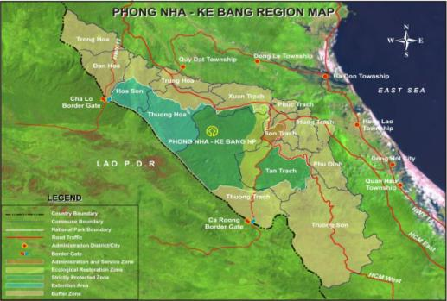
THE Management Vision
That the world heritage values and other natural, cultural and historical values of Phong Nha - Ke Bang National Park are promoted and conserved with integrity; local communities’ lives are improved; tourism to the park region satisfies international standards; and park management meets the requirements of a World Heritage Site.

tABLE OF CONTENT
1. INTRODUCTION 3
1.1 Purpose of the Strategic Management PlaN 4
1.2 Preparation and Planning Process 6
1.3 World Heritage Background 7
1.4 Ownership and Control 7
1.5 World Heritage Management Obligations 8
1.6 World Heritage Values 8
1.7 Other Heritage Values 10
1.8 Management Background and Regional Setting 11
1.8.1 Regional Context 11
1.8.2 Land Tenure and Use Rights 12
1.8.3 Land Use 13
1.8.4 Administration 14
1.8.5 Legal Basis 15
1.9 Threats and challenges 16
1.10 Necessity of management planning 14
2. MANAGEMENT STRATEGIES 15
2.1 OVERALL management objectives 15
2.2 Main Issues 16
2.2.1 Protecting geodiversity 17
2.2.2 Conserving biodiversity and evolutionary processes 19
2.2.3 Protecting historical and cultural values 22
2.2.4 Protecting and enhancing integrity 24
2.2.5 Appropriate presentation of heritage and tourism management 27
2.2.6 Addressing livelihoods issues 30
2.2.7 Developing capacity and supporting management 33
SELECTED REFERENCES 37
ANNEXES - 1 -
Annex I. Brief history of Phong Nha- Ke Bang National Park - 1 -
Annex II. Recognized World Heritage Values: Geomorphology and Earth history - 2 -
Annex III. Potential World Heritage Values: Evolutionary Processes and Biodiversity - 3 -
Annex IV. Other Heritage Values - 6 -
Annex V. Institutional Framework - 11 -
Annex VI. Organisation and management - 12 -
Annex VII. Human Population - 13 -
Annex VIII. Inholdings - 15 -
Annex IX. Relevant Laws and Regulations - 16 -
Annex X. Environmental Impact Assessment Process - 18 -
Annex XI. Analysis of Threats - 19 -
Annex XII. Regulations for Sub-Zones of the National Park - 24 -
Annex XIII. Guidelines for a Visitor Management Plan for PNKB NP WHS - 27 -
Annex XIV. Cave Management and Cave Management Prescriptions - 28 -
Annex XV. UNESCO Man and the Biosphere Program and Biosphere Reserves - 31 -
Annex XVI. Considerations for review of all tourism plans - 32 -
Annex XVII. Forest Conservation and Investment Contracts - 33 -
Annex XVIII. Training Plan Summary - 36 -
Annex XIX. Design of Monitoring Protocols - 37 -
Annex XX. Monitoring Plan Summary - 38 -
List of key contributors and participants in the planning process - 40 -
PROJECT SUPPORT - 42 -
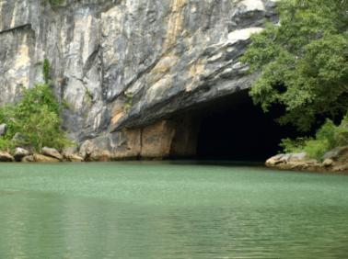

The entrance to Phong Nha Cave. Photo: Graeme L. Worboys.

INTRODUCTION
This Strategic Management Plan covers the complete Phong Nha – Ke Bang National Park (PNKB NP) Region. The PNKB NP Region comprises an area that includes the entirety of the PNKB NP (the World Heritage Site (WHS) and Extension Area) as well as 13 communes in three districts that border the National Park boundaries (the Buffer Zone).

The area managed by the PNKB National Park Management Board covers 123,326 hectares (ha), which is divided into three functional areas: a) Strictly Protected Area: 102,466 ha, b) Ecological Restoration Area: 17,449 ha and c) Administrative and Service Area: 3,411 ha. Of this area, 85,754 ha was recognized as a National Park by the Vietnamese government in 2001 and as a World Heritage Site by the UNESCO World Heritage Committee in 2003. An extension of 37,572 ha, already protected and zoned as Strictly Protected Area, has been proposed as an addition to the National Park and World Heritage Site.

World Heritage listing is the highest level of international recognition that may be afforded to an area, acknowledging its outstanding universal values and global significance. PNKB was inscribed on the list of World Heritage sites on the basis of its outstanding natural values. The karst formation of Phong Nha-Ke Bang National Park has evolved since the Paleozoic (some 400 million years ago) and so is believed to be the oldest major karst area in Asia. The vast karst area, extending across the border into the Lao People’s Democratic Republic, contains spectacular formations including over 104 km of caves and underground rivers, making it one of the most outstanding limestone karst ecosystems in the world. Karst formation processes have led to the creation of a variety of cave types, including underground rivers, dry caves, terraced caves, suspended caves, dendritic caves and intersecting caves.

PNKB Park and adjacent forest land support an enormous number of species, including over 2,851 vascular plant species and over 755 vertebrate species, including 113 mammals, 302 birds, 81 reptiles and amphibians, and 72 fish. Over 70 of these vertebrate species are considered globally threatened, and ten primate species and subspecies are known from the Park. The region supports a large number of endemic and relict species, such as Soala, Giant- Antlered Muntjac and Annamite Striped Rabbit. Several of these species are specialists on karst or cave ecosystems, such as the Laotian Rock Rat, Hatinh Langur, Sooty Babbler, Annamite Flying Frog and two species of blind cave scorpions (the first discovered in mainland Asia). These endemic and relict species are the result of evolutionary processes that are still ongoing in the region.

Phong Nha – Ke Bang region has major historical significance because of the role that it played during the long war with America. Many routes of the Ho Chi Minh Trail and Victorious Road 20 run through the Park, and its caves and forests served as strategic bases and refuges during the war. The region is rich in stories, both tragic and heroic, and has deep meaning for the people of Vietnam.

.

.
  - Purpose of the Strategic Management PlaN
This Strategic Management Plan has been prepared to assist in meeting Vietnam’s international responsibilities under the World Heritage Convention. It will ensure that appropriate consideration is given to the PNKB National Park World Heritage site’s Outstanding Universal Values by government authorities when making decisions and by managers when developing management proscriptions for the Park and the surrounding area. It will also ensure that these actions are taken in a coordinated way, consistent with the mission of the Park. This document also serves as a commitment of the management agencies to the long-term survival of PNKB National Park and the protection of its values.

The Strategic Management Plan is part of an overall planning framework for the World Heritage Site and surrounding region. It does not attempt to provide details of background and management actions. Detailed management prescriptions and process for implementation are provided in other documents, particularly the three planning documents developed in parallel with the Strategic Management Plan: The National Park Operational Management Plan (POMP), The Sustainable Tourism Development Plan (STDP) and the Buffer Zone Development Plan (BZDP). Diagram 1 provides a summary.

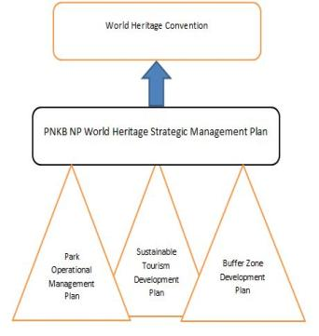
The Strategic Management Plan outlines strategies proposed for protection and compatible development of the entire PNKB region over the next 12 years. Under this framework, the National Park Management Board will undertake routine management of the National Park, while local government will promote development and regulate activities in the Buffer Zone, all under the supervision of the Quang Binh Provincial People’s Committee. The strategic management plan can serve as a foundation and guide for developing the operational management plan and other plans that affect the National Park. The Plan will ensure a greater level of consistency with the mission of the World Heritage Site, and improve coordination between the Park and relevant government agencies in the Province. The Strategic Management Plan is not a legal document in its own right, but by agreeing to the content of this document, relevant agencies make a commitment to abide by its principles and to implement the strategies as outlined.
Figure 1: A summary of PNKN National Park Strategice Plan struture

  - Preparation and Planning Process
The Strategic Management Plan is designed to ensure that management within the National Park and development activities within the surrounding region are complementary, coordinated and consistent with the mission of the World Heritage Site. It has been prepared with the funding of the Nature Conservation and Sustainable Management of Natural Resources for the Phong Nha Ke Bang National Park Region Project, acting as a foundation for the Provincial People’s Committee to instruct and guide Phong Nha - Ke Bang National Park Management Unit and other government agencies to issue appropriate policies and formulate management activities.

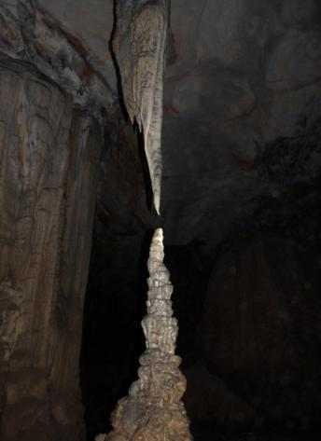
Preparation of the Strategic Management Plan has been guided by the World Heritage Convention and the Statements of Outstanding Universal Values prepared for World Heritage nomination, as well as all relevant government decrees, decisions and circulars. The Strategic Management Plan is based on information in plans already developed or under development by the Nature Conservation and Sustainable Management of Natural Resources in the Phong Nha - Ke Bang National Park Region Project, particularly the Sustainable Tourism Development Plan (completed), the National Park Operational Management Plan and the Buffer Zone Development Plan (under development as of 2012). These three plans are the result of extensive and intensive surveys and consultation, with participation of representatives of local government and members of the communities living in the Park and Buffer Zone (summarized in the BZDP), participation of representatives of stakeholders from private enterprise (in the STDP), and participation of line staff of the National Park (in the POMP).
Stalactite and stalagmite grow towards each other inside Paradise Cave, one of the most popular sites in Phong Nha – Ke Bang National Park World Heritage Site.

The Strategic Management Plan will be current until 2025 and will be reviewed periodically. This timeframe has been chosen as a realistic medium-term planning horizon that provides a realistic period within which the identified management responses can be implemented, and their impacts and effectiveness evaluated.
  - World Heritage Background
The World Heritage Convention was established under the auspices of the United Nations in 1972. It aims to promote cooperation among nations to protect the world’s natural and cultural heritage. By ratifying the Convention on 19 October 1987, Vietnam became one of the 189 countries to commit to the identification, protection, conservation and suitable presentation of World Heritage sites.

The World Heritage Convention is administered by the World Heritage Committee, composed of 21 member nations elected from among the state parties to the Convention. Under the Convention, a list of “properties” having outstanding universal value has been established; the World Heritage List. Only the national government of a country that is a party to the Convention may nominate an area within its jurisdiction for World Heritage listing. The World Heritage List included 962 sites worldwide at the time of writing, including 745 cultural, 188 natural and 29 mixed properties in 157 States Parties. The list only includes sites of global importance, such as the Pyramids of Egypt, the Grand Canyon in the USA, the Great Barrier Reef in Australia and Mount Everest, the highest mountain in the world. There are currently seven World Heritage sites in Vietnam.

In order to qualify for World Heritage listing, a nominated site must meet specific natural and/or cultural criteria that demonstrate outstanding universal value. The site must also possess sufficient integrity, meeting strict conditions before it can be listed. A listed site may be assigned to the list of Sites in Danger or even removed from listing if it loses its integrity or no longer meets the criterion for which it was listed.

  - Ownership and Control
World Heritage listing does not affect ownership rights or control of World Heritage properties. In the case of Phong Nha-Ke Bang National Park, the Park remains under the jurisdiction of the Provincial People’s Committee of Quang Binh Province and is managed by government agencies in accordance with relevant decrees, decisions and circulars.

The government agency in Vietnam directly responsible for management of the National Park is the PNKB National Park Management Board, which reports directly to the People’s Committee of Quang Binh Province.

  - World Heritage Management Obligations
The government of Vietnam recognizes its duty of ensuring the identification, protection, conservation, presentation and transmission to future generations of all of its cultural and natural World Heritage sites. Through Article 5 of the World Heritage Convention, the government has made an international commitment to do all it can to this end, to the utmost of its own resources.

In order to ensure that effective and active measures are taken for the protection, conservation and presentation of the cultural and natural heritage situated on its territory, each State Party to this Convention shall endeavor, in so far as possible, and as appropriate for each country:
(a) to adopt a general policy which aims to give the cultural and natural heritage a function in the life of the community and to integrate the protection of that heritage into comprehensive planning programs;
(b) to set up within its territories, where such services do not exist, one or more services for the protection, conservation and presentation of the cultural and natural heritage with an appropriate staff and possessing the means to discharge their functions;
(c) to develop scientific and technical studies and research and to work out such operating methods as will make the State capable of counteracting the dangers that threaten its cultural or natural heritage;
(d) to take the appropriate legal, scientific, technical, administrative and financial measures necessary for the identification, protection, conservation, presentation and rehabilitation of this heritage; and
(e) to foster the establishment or development of national or regional centers for training in the protection, conservation and presentation of the cultural and natural heritage and to encourage scientific research in this field.

  - World Heritage Values
World Heritage Values of PNKB NP are outstanding universal values that are directly related to the criteria for which an area is included on the World Heritage List.

PNKB National Park World Heritage Site was inscribed on the World Heritage List in 2003 because it satisfies World Heritage Natural Criterion viii Geomorphology and Earth History as
- an outstanding example representing major stages of earth's history, including the record of life, significant on-going geological processes in the development of landforms, or significant geomorphic or physiographic features (Criterion vii).

Phong Nha – Ke Bang, together with Hin Namno karst (in Lao PDR) is probably one of the finest and most distinctive examples of a complex karst landform in Southeast Asia. The karst formation of PNKB NP WHS has evolved since the Paleozoic (some 400 million years ago) and so is believed to be the oldest major karst area in Asia. The vast karst area contains spectacular formations including over 104 km of caves and underground rivers, making it one of the most outstanding limestone karst ecosystems in the world. The karst formation processes have led to the creation of a variety of cave types, including underground rivers, dry caves, terraced caves, suspended caves, dendritic caves and intersecting caves.

Phong Nha-Ke Bang NP WHS has other outstanding values that have the potential to qualify for World Heritage listing in their own right. It has recently been proposed that PNKB National Park, in its extended form, should also be nominated for World Heritage listing under World Heritage Natural Criterion ix as
- an outstanding example representing significant on-going ecological and biological processes in the evolution and development of terrestrial, fresh water, coastal and marine ecosystems and communities of plants and animals.

PNKB National Park protects a large portion one of the best preserved tracks of limestone forest in the central Truong Son range, which has been recognized as a critical landscape of the Greater Annamites Global 200 Bioregion. Many endemic and near-endemic vertebrates are associated with this ecoregion, which has been identified as one of the greatest concentrations of endemic species in a continental setting found anywhere. PNKB is the key protected area in the Central Indochina Limestone Landscape, the most extensive limestone area holding the most distinctive limestone community in the Greater Annamites Ecoregion. This area is critical for the conservation of primate species and limestone specialist species. The persistence of more primitive or relict species could be attributed to long-term habitat stability in the region, the effect of a stable climate and of regular uplifts over a long period maintaining a suitable distribution of habitat types. Central Vietnam’s uplands and associated lowland areas appears to be a focal point or hotpot of endemism within mainland Southeast Asia. Cave fauna in particular show the striking effect of isolation on species divergence.

PNKB NP WHS should also be recognized for its global importance in in-situ conservation of biological diversity under World Heritage Natural Criterion x as
- containing the most important and significant natural habitats for in-situ conservation of biological diversity, including those containing threatened species of outstanding universal value from the point of view of science or conservation.
Of perhaps the greatest conservation significance are several species found at the site that are endemic to this part of central Vietnam and Laos. Almost 94% of the property is forested, and 84% of this is old-growth forest. The property is also recognized as part of a Global 200 priority ecoregion, an Indo-Burma global biodiversity hotspot and an Endemic Bird Area that is not otherwise represented on the World Heritage List.

  - Other Heritage Values
Apart from the features which are recognized as having World Heritage value, Phong Nha – Ke Bang has numerous other outstanding values that complement and interface with its World Heritage values. Protection of all of these values is an integral part of managing PNKB NP WHS and the greater PNKB region.

Historic and Archeological Values: PNKB NP WHS includes numerous places of great historic and archeological significance. A long history of human occupation has left many archeological relicts, such as Cham inscriptions inside caves, PNKB became a key theatre during the US-Vietnam War. The Ho Chi Minh trail, including Road 20 to Lao PDR and associated trails in and near the Park, were key transportation routes for the war effort.
Indigenous Culture and Cultural Diversity: Approximately 11,000 inhabitants of the Phong Nha - Ke Bang region are from ethnic minorities. Much of their traditional way of life is linked with the use of natural resources from the forests of Phong Nha- Ke Bang, and these communities still retain significant indigenous knowledge about the caves, the forest and the uses of its species.
Recreation and Tourism: Because of the intrinsic beauty of its caves and of the forested karst landscape, all easily accessible from major population centres in Vietnam, PNKB has outstanding recreational values. PNKB provides opportunities for quality recreation and tourism experiences that are increasingly in demand, and rare by world standards.
Social and Economic: The regional economy surrounding PNKB is receiving increasing support from tourism. The Park has considerable social and economic value and contributes directly and indirectly to employment, to income and to government revenue in the region. Visitation to the PNKB NP Region has increased considerably recently from approximately 80,582 in 1999 to over 366,753 in 2011 reflecting the Park’s increasing importance as a destination for both day trips and longer stays..
Research and Education: The complexity of its geomorphology and the richness of its biodiversity and ecosystems make the PNKB NP WHS an ideal area for research and education.
Scenic, Aesthetic, Inspirational and Existence: The dramatic karst landscape of PNKB WHS provides a scenic landscape of extraordinary beauty full of inspiring wonders. Simply knowing that wild areas such as these exist and are protected forever is a value for many people throughout the world, even among those who may never be fortunate enough to visit the WHS.
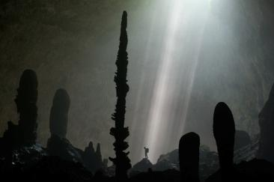
Inside Son Doong Cave, the world’s largest cave by volume.
Photo: Carsten Peter for National Geographic.

  - Management Background and Regional Setting

    - Regional Context

The PNKB NP World Heritage Site property as currently gazetted consists of 85,754 ha, with a total contiguous protected area covering 123,326 ha. The PNKB NP Region is located in the western part of the Quang Binh Province, about 45 km by road from the provincial capital Dong Hoi City, 370 km south of Hanoi and 765 km north of Ho Chi Minh City as the crow flies.

The PNKB NP WHS is situated in the narrowest portion of Vietnam between Laos and the Tonkin Gulf, making it possible to visit the Park in the morning and return to the coastal beach by evening. The Ho Chi Minh West Highway traverses the Park from northeast to southwest. While not heavily travelled, this is an important security road for use in cases of flooding or other interruptions to roads in the lowlands. National Road 20, a narrow road northeast to southwest through the middle of the Park, connects Dong Hoi directly with Savanakhet in Lao PDR. This road is considered important for regional development by provincial authorities. These all-season roads provide access for tourists to most of the open tourist sites in the Park.

Most visitors to PNKB arrive via the provincial capital Dong Hoi or from nearby Hue, which are served by train and bus service along the major north- south transportation corridor. Dong Hoi and Hue also have airports that receive daily flights from Hanoi and Ho Chi Minh City. The region is one of the most popular tourist destinations in central Vietnam. Over the past decade, visitor numbers to Quang Binh Province have grown significantly from approximately 135,000 in 1999 to nearly 961,425 in 2011. Domestic visitors make up the majority of these visitors and only approximately 2.7% were of international origin.

The PNKB NP is contiguous along its north-western boundary with Hin Namno National Biodiversity Conservation in Khammoune Province Lao PDR. Together, these two protected areas comprise the largest area of contiguous protected karst habitat in mainland Southeast Asia, protecting a critical part of the Central Indochinese Limestone Landscape. The Buffer Zone surrounds PNKB NP on all other sides. The extended Buffer Zone includes 11 communes adjacent to the National Park and two additional communes, one of which is adjacent to Hin Namno NBCA in Lao PDR (and thus important for connectivity of PNKB habitats).

    - Land Tenure and Use Rights
The PNKB Region is made up of the PNKB National Park and a surrounding Buffer Zone. The extended Buffer Zone of 13 nearby communes covers a total area of 220,950.77 ha and supports over 65,483 people, most of whom are small-hold farmers.

The PNKB NP area, including the World Heritage Property and the newly added extension, is all managed as “special-use forest” land, protected under Vietnamese forest law and managed by the National Park Management Board. In the Buffer Zone, except for a few small minority communities practicing shifting cultivation, usufruct for all designated agricultural land is allocated to households through land use certificates. Several State Forest Enterprises operate in the Buffer Zone and have forest use rights.

There are currently two villages with 78 households and 444 ethnic minority people living inside the PNKB NP WHS property. Nothing in this document is intended to diminish in any way their land rights or user rights, either legally recognized or customary.

A Tourism Area within the NP WHS Ecological Restoration Area has been leased to a private company on a 50 year lease until 2061. The area provided includes 55 hectares of protected forest land and the entire karst of the Paradise Cave and Mother Embracing Child Cave.

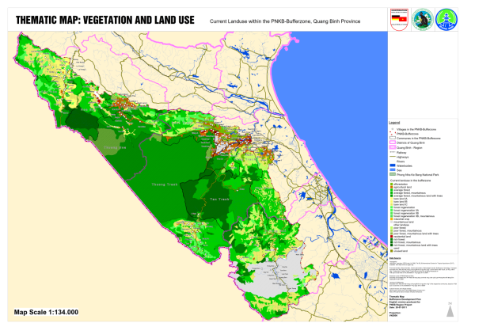

    - Land Use
The total perimeter of PNKB National Park and extension area is over 200 km long. With the exception of the boundary contiguous with Hin Namno NBCA in Lao PDR, this perimeter is adjacent to lands that are used by local people. The activities of these people have the potential to significantly impact the values of PNKB NP WHS and it Outstanding Universal Values.

The dominant resource and land use throughout the Buffer Zone around the National Park and extension area is forest land and forestry, covering 202,972 ha. Of this total, more than half (108,791 ha) is under the management of state forest enterprises and Protection Forest Management Boards, and the remainder (94,181 ha) is managed by the communes of the Buffer Zone.

As of 2012, the Buffer Zone included 154 villages and hamlets in 13 communes in three districts, with 14,114 households comprising 64,243 people. The total area of agricultural land in the PNKB NP Region is about 7,074 ha, resulting in major constraints for local livelihoods. Only a fourth (1,255 ha) of this is irrigated land, explaining the generally low productivity. The average agricultural land per household is 0.50 ha. Unused land (barren forest land and fallow agricultural land) and other land amounts to an estimated 8,230 ha.

Kinh settlers in the lowlands of the Buffer Zone rely on an agricultural base of intensive irrigated rice production combined with livestock, home gardens and a small upland component. Ethnic minorities in the region used to generate their income mainly from shifting cultivation and forest resources extraction in the hilly areas. However, due to sedentarisation programmes, this livelihood strategy has become less important and now only involves about 2,000 households in the greater PNKB Region. Still, these households typically continue to rely on forest resources as their primary year-round food and income source. Ethnic minority groups often receive rice subsidies sometime associated with annual forest protection contracts.

Both intensive and shifting livelihood systems are under serious pressure due to high population growth and medium to poor soil fertility, as well as very limited availability of agricultural and forest land in general. The latter point is partly a result of land reallocation during the creation of the National Park. As a result there is a high poverty rate in some communes of the Buffer Zone. With few alternatives, many people in the PNKB Region rely on illegal logging, hunting, and collection of forest products to supplement their incomes, creating a significant threat to the World Heritage values of the Park, particularly its forests and their biodiversity.

Local people hunt, log and collect medicinal plants in part to sell forest products to middlemen and traders. This is difficult for the Park to control, because many local people have few alternative means of earning income. Some isolated and cash-poor minority communities have traditionally relied on hunting, fishing and collection in the forest to provide for their subsistence needs. Most communities living adjacent to the Park rely on the forest for fuel wood, lumber, and grazing land.

    - Administration
The Provincial People’s Committee of Quang Binh Province has the highest level of authority and responsibility for managing and monitoring activities in the PNKB NP Region. PNKB NP Management Board is a unit directly under the PPC of Quang Binh. The Director of the Park is also the Director of the National Park Management Board. Management of the National Park and the Extension Area is carried out by the National Park staff, who are line staff under the Ministry of Agriculture and Rural Development.

The institutional framework for management and monitoring of the PNKB NP Region is complex and relies upon close inter-agency cooperation for effectiveness. A summary is provided in Annex V.

Figure 2 illustrates the general institutional framework for the PNKB NP Region.

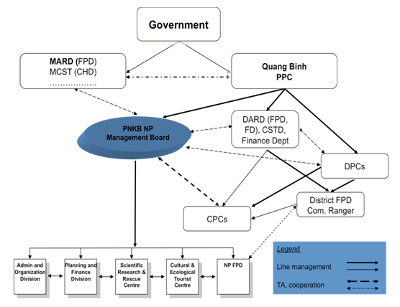

MARD – Ministry of Agricutlure and Rural Development
MCST – Ministry of Culture, Sports and Tourism
PPC – Provincial People’s Committee
FPD – Forest Protection Department
DARD – Department of Agriculture and Rural Development
CSTD – Department of Culture, Sports and Tourism
DPC – District People’s Committee
CPC – Commune People’s Committee

    - Legal Basis
Phong Nha Ke Bang National Park was created by Decree 189 of the Prime Minister in 2001, and is regulated through Decision No. 18/2007 of the Quang Binh Provincial People’s Committee and other relevant laws and regulations.

The National Park came into existence with the upgrading Phong Nha- Ke Bang Nature Reserve to National Park status by the Prime Minister. The Park was subsequently expanded to its current size.

From its inception, the Park was assigned the following objectives and tasks:
- Organize to protect forest resources and the abundant and diverse forest ecosystem within the planned boundary of the Park;
- Conserve scientific value of typical fauna & flora species of the central area, especially primate species and the newly described species;
- Establish and develop national park infrastructure facilities and create favorable condition for research, conservation of typical fauna & flora in the Core Zone as well as strengthening domestic and international scientific research cooperation and hosting trainings and study tours;
- Exploit the strength and potential of beautiful spots by developing eco-tourism and providing guidelines and job creation for local communities and in addition encouraging them to participate in tourist activities for improvement of their living standards, environmental and ecological protection and local socio- economic development.

The management of the land and natural resources of the National Park and Buffer Zone are governed by relevant laws and regulation on National Parks and special use forest, as well as laws on environmental protection, land use, tourism development and law enforcement. Important laws, decrees, decisions and circulars are listed in Annexes VI and VII.
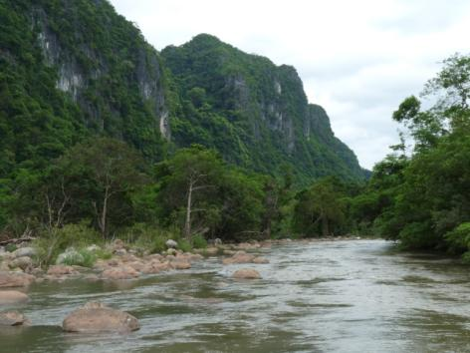

  - Threats and challenges
In common with many protected areas, PNKB NP WHS faces a range of external threats to its immediate and long-term integrity. The threats vary in their scale and scope, from localized pressures created by tourism and road development to threats to biodiversity from widespread hunting and timber poaching. Internal constraints also limit the Park’s ability to respond effectively and counter these threats.

The strategic threats fall into 10 categories, listed in order of their seriousness and the severity of their impacts on the values of PNKB NP WHS:

- Wildlife hunting and trapping
- Illegal logging
- Non-timber forest product exploitation
- Destructive tourism
- Infrastructure developments inside the Park
- Invasive and alien species
- Firewood collection
- Cattle grazing in the Park
- Fishing
- Forest land encroachment
- Cinnamomum oil extraction
- Forest fire
- Natural disasters

Each of these issues is considered a substantial threat to the on-going integrity of PNKB NP and its recognized or proposed World Heritage values (see Annex VIII).

The size of PNKB and the inaccessibility of much of its forests provide some measure of protection against these threats. Any increase in accessibility of the interior of the Park, however, may compound the impact of these threats.

Several serious internal constraints prevent the Park from responding effectively to these and other threats. During the development of this management plan a number of issues emerged regarding capacity of PNKB Park for conservation, protection and management during the last five years. Weaknesses included:

- Annual funds allocated to the National Park were much less than the planned budget in the investment plan requested by the PNKB NP Management Board;
- A lack of human resources in terms of both number and capacity of staff;
- Weak inter-agency coordination in forest law enforcement;
- A lack of funding for buffer zone projects; and
- A lack of good governance.
A young gibbon Nomascus siki rescued from the wildlife trade
and sent to the Phong Nha –Ke Bang National Park Wildlife Rescue Center.

  - Necessity of management planning
In order for the National Park Management to overcome constraints, respond effectively and counter threats, all within the limits of the budgetary support at its disposal, careful planning is required.

Article 108-109 of the Operational Guidelines for the Implementation of the World Heritage Convention make clear that “Each nominated property should have an appropriate management plan or other documented management system which must specify how the Outstanding Universal Value of a property should be preserved, preferably through participatory means. The purpose of a management system is to ensure the effective protection of the nominated property for present and future generations.”

According to Decree 117 of the Government of Vietnam, the National Park management unit must make 5-year plans and submit them to the Forestry Directorate for approval, covering public information activities; forest management, protection, construction, development and use; nature conservation; scientific research and experimentation; rescue of wild fauna and flora: service activities; labour management and use; construction investment; and finance. The Operational Management Plan is designed to fulfil this requirement. Required information about Ecotourism Development and planning for Buffer Zone Development are covered in the Sustainable Tourism Development Plan and Buffer Zone Development Plan respectively.

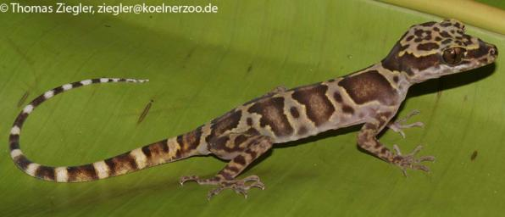

Crytotodactylus crispus, a gecko recently discovered inside Phong Nha – Ke Bang National Park World Heritage Site. Numerous new species have been discovered in the region, underscoring its global significance for biodiversity.

This Strategic Management Plan and accompanying operational plans are designed as an integrated set covering all aspects of management of the PNKB NP WHS region. They are designed not only to fulfil the requirements of the World Heritage Convention and Vietnam law, but also to guide the management of the Park until 2025 to insure the continued integrity and protection of the outstanding values the Park protects, while arranging for fair livelihoods for local people and appropriate presentation of those values to the people of Vietnam and the world.

MANAGEMENT STRATEGIES
  - OVERALL management objectives
World Heritage status is the highest level of recognition that may be afforded to any protected area. It places an important responsibility on the government of Vietnam to apply the highest possible standards of management practice.

A set of key strategic objectives for the PNKB NP WHS, which provides a philosophical basis for the management of the PNKB region and guidance in the formulation of operational management strategies, has been derived from the World Heritage Convention and its Operational Guidelines. These objectives are consistent with World Heritage management principles and with the laws and policies of Vietnam.

Strategic objectives for management of the PNKB NP WHS are to:

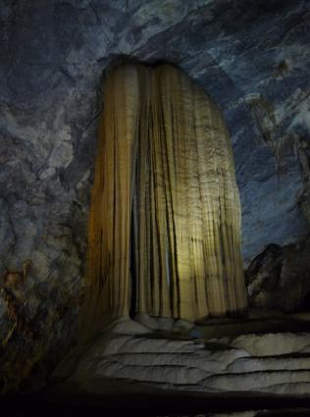
- Identify, protect, conserve, present, transmit to future generations and, where necessary, rehabilitate the World Heritage values of PNKB NP WHS;
- Integrate the protection for the PNKB NP WHS into a comprehensive planning program for the entire PNKB Region;
- Give the PNKB NP WHS a function in the life of the community of Vietnam;
- Strengthen appreciation and respect for the PNKB’s World Heritage values, particularly through education and information programs, keeping the community broadly informed about the condition of the World Heritage values of PNKB NP WHS;
- Take the appropriate scientific, technical, legal, administrative and financial measures necessary for implementing these principles;
- Provide for continuing community and technical input in management of PNKB NP WHS; and

- Manage the broad range of values, both World Heritage and non-World Heritage, ensuring that achieving the long-term conservation of the PNKB’s World Heritage values is the over-riding principle.

In order to achieve these objectives, a number of key management issues need to be addressed. The remainder of this document outlines the proposed management objectives and responses to achieve desired outcomes by 2025.
  - Main Issues
The management strategies and actions outlined below address those threats and issues that are considered strategic priorities for the overall integrity of PNKB NP WHS and the protection of its outstanding universal values.

The key management issues have been grouped in the following categories
- Protecting geodiversity
- Conserving biodiversity
- Protecting historical and cultural values
- Enhancing integrity
- Appropriate presentation
- Addressing livelihoods issues
- Developing capacity and professionalism for management

The management strategies below provide strategic directions for both proactive management and responsive adaptive management, through active enforcement, awareness building, community outreach, alternative livelihoods, and tourism development. Through community consultation and involvement, appropriate presentation and education, and interagency cooperation, the Park will also seek the cooperation and support of the Park’s neighbours and the broader community to achieve the World Heritage objectives. Finally, building the capacity and professionalism of the Park staff and a knowledge base through scientific monitoring and research are critical to effective implementation of all other management activities.

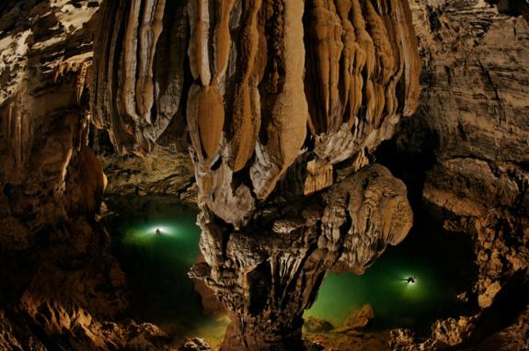

Two cavers are dwarfed by the cavern inside Son Doong Cave, the world’s largest cave
by volume. Phone Carsten Peter through National Geographic.
    - Protecting geodiversity

Management Objective
To effectively manage Phong Nha - Ke Bang National Park’s recognized world natural heritage, including its scenery; karst environments; karst hydrology; karst processes; geology; geomorphology; soils; and caves with all their formations and speleothems, natural air quality, meteorology, biodiversity and cave ecosystems.

Background
The outstanding universal value of PNKB’s karst and caves has been recognized worldwide. This in turn has brought ever increasing numbers of visitors to the Park. While presentation of World Heritage values is one of the recognized missions of World Heritage sites, planners and managers need to assess and respond to potential and current impacts of tourism and supporting infrastructure development, both inside the National Park and in the surrounding environment, on the features of outstanding universal value in the karst landscape and caves.
The National Park Management has authority to control use of surface natural resources within the National park, thus protecting most surface features of the karst landscape. The National Park also controls access to the entrances to all of the caves inside the World Heritage Site. Currently, the legal authority for protection inside caves in Vietnam is unclear and management authority of the National Park may be too weak. The provincial Department of Natural Resources and Environment has authority over development of all sub-surface resources in the province. Additional legal protection may be needed for sub-surface features in a karst landscape (i.e., the caves). For example some protected areas in Australia are dedicated to the centre of the Earth, and this provides effective protection of subsurface features such as caves.

Desired Outcomes
- Protection planning, management measures and monitoring systems for protection of World Heritage caves and karst landforms in PNKB NP WHS are in place and operating effectively.
- The effects of human activities on karst landforms and caves in PNKB NP WHS are compatible with long-term protection of karst and caves, both inside the World Heritage property and in the surrounding Buffer Zone; quarries and earth mining are not destroying vulnerable karst landforms; surface development is not degrading the karst hydrological regime; catchments of underground rivers are not polluted; tourism is not damaging karst and caves and their features of outstanding universal value.

Management Response
- Identify needs for and effectively manage the protection of the entire surface and sub-surface Karst catchments and Karst hydrological regimes.
- Regularly monitor for any non-natural disturbance to any part of the Karst surface and sub-surface catchments as a basis for rapid response to threats.
- Assess the risk of threats and plan for and respond to any impacts to Karst surface and sub-surface environments, especially from petroleum or chemical pollution.
- Work with researchers to identify the nature of cave biodiversity and cave ecosystems as a basis for effective management.
- Actively manage to retain intact the large areas of the Park in all management zones, including protecting the natural forest, restoring disturbed sites, removing weeds, and preventing additional disturbance.
- Promote and encourage conservation management in the Buffer Zone and especially areas above and upstream of cave rivers so as to encourage protection of soils and watersheds and to discourage incompatible development.
- Understand and monitor the natural atmosphere and meteorology of caves as a basis for effectively conserving cave environments.
- For all existing and proposed tourist caves inside the World Heritage property, which are all World Heritage Karst sites, prepare individual Tourist Cave Management Plans that facilitate the protection, restoration and professional presentation of the caves.
- Work with researchers and speleologists in the development of a Wild Cave Protection, Access and Conservation Management Plan for the National Park, based on the approach of management prescriptions (see Annex XI).
- Prepare legal agreements for any tourism operations within the World Heritage property so that they recognise and are compliant with the provisions of the PNKB Management Plan and associated supplementary specific plans.

Monitoring for this Objective will focus on threat reduction, water quality, air quality, presence/absence of key indicator species populations, and the condition of speleothems and other key cave features.

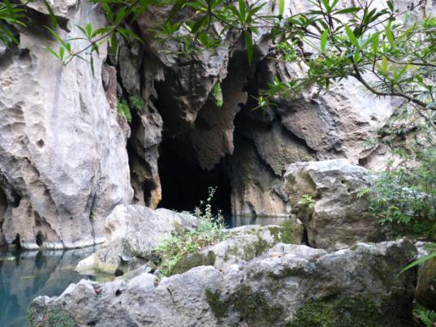

The entrance to an undeveloped wild cave inside Phong Nha – Ke Bang National Park World Heritage
Site. Over 350 cave entrances have been discovered inside the Park. Most are unexplored.
    - Conserving biodiversity and evolutionary processes

Management Objective
To conserve and understand the Phong Nha - Ke Bang National Park World Heritage fauna and flora, habitats and supporting natural ecological and biological processes to help ensure ecological viability, the on-going development of terrestrial and aquatic ecosystems and on-going evolution of species, both surface and sub-surface.

Background
To conserve the values of PNKB for biodiversity and evolutionary processes, management aims to protect and conserve in-situ natural ecosystems and their associated ecological processes, species populations and genetic diversity. This includes terrestrial, subterranean, and aquatic ecosystems and their interrelationships.

Key to achieving these goals is a reduction in the unsustainable harvesting of wild flora and fauna. This will be achieved through a three-pronged approach, (i) awareness building to encourage behavioral change, targeting those who harvest, the consumers who create the demand and the middle-men and,(ii) providing alternatives to local people who are dependent on harvesting the Park’s forest resources for their subsistence or income, and (iii) effective enforcement of laws and regulations designed to protect wildlife and habitats.

Ecosystem conservation requires the protection of forests from habitat degradation and destruction through firewood collection, grazing and encroachment of agricultural land. This will also require alternatives for those community members who currently have no alternative sources of fuel, pasture or agricultural land. This issue is dealt with in the 4th Objective.

Maintaining ecosystems, biodiversity, and ecological and evolutionary processes also depends directly on the integrity of the Park and its habitats, their overall size and connectivity. This is dealt with in the 3rd Objective.

Desired Outcomes
- Hunting and illegal logging activities are reduced substantially, with zero tolerance towards illegal activity.
- Collection of Non-timber Forest Products (NTFPs) and fishing is reduced to ecologically sustainable levels.
- Firewood collection, grazing and clearance of forest in and around the Park by villagers who still depend on these activities is reduced and controlled so that it does not damage the Park’s World Heritage Values.

Management Response
Awareness raising for behavioral change
- Awareness raising among villagers: This effort will focus on changing behaviors in order to reduce unsustainable hunting, particularly of species of high conservation concern. Awareness raising for indigenous people will emphasize the availability of alternative medicines and meat (see below).
- Awareness raising among visitors and tourists: A key cause of hunting in the Park is the brisk market for wild meat, medicines and live wild animals that has grown up around the Park. While the Park must rely on other actors to stem the loss of wildlife to consumers throughout Vietnam, it can focus efforts on increasing awareness among visitors to the Park. Key messages will include the fact that purchasing wildlife is contributing to the loss of species and the degradation of the Park threatening its status as a World Heritage Site. The message will also include information about regulations, including the consequences of being caught with illegal wildlife purchases.
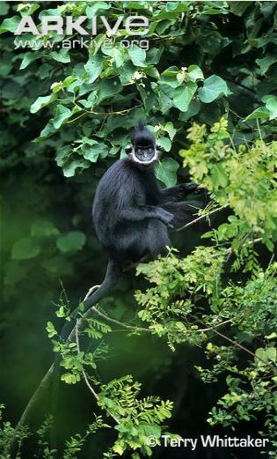
- Awareness raising among consumers of timber: The market for high value timber from the National Park is driven by a network of traders that bring these products to consumers. The Park will participate in national campaigns to stop the illegal harvest and trade of protected timber species, and can also target visitors and local people with campaigns to increase awareness and stop purchases of protected species. (Logging for household use is dealt with separately below.)
- Awareness raising among local loggers: Many local villagers harvest timber from the Park on behalf of outsiders. The Park will target loggers and potential loggers with information about which species are protected, how the Park is enforcing the laws, and what the consequences are for forest crime.
- Awareness raising among wildlife traders and restaurant owners: This target group is a key actor in the decimation of wildlife in the Park through hunting. The Park will enlist the support of local government and enforcement authorities to pressure this group into commitments to stop their illegal activities.

- Awareness raising among collectors and suppliers of NTFPs: Collectors and suppliers are key actors in the decimation of wildlife in the Park through hunting. In addition to the awareness raising campaign described above, the Park will seek the support of local government and enforcement authorities to pressure this group into making commitments to stop illegal activities.
- Awareness raising among consumers of NTFPs: A key reason for collection of NTFPs is for use as traditional medicines. Awareness raising for this target group will therefore emphasize the availability of alternative medicines. Target groups include both local people and visitors and tourists. Key messages will include the fact that purchasing protected species degrades the Park, threatening its status as a World Heritage Site. The message will include information about regulations, including which species are protected and the consequences of wildlife crime.

Provision of alternatives to communities dependent on the Park’s natural resources
This is vital to reducing consumption of natural resources inside the Park. See the Fourth Objective below for details.

Effective Law enforcement to end illegal hunting and logging
- Strengthen law enforcement to stop sales and consumption of wildlife: This highest priority activity will focus on patrolling and guarding to deter hunters and to catch habitual offenders. Patrolling Plans for each Guard Station will be designed to optimize effectiveness of the anti-hunting impact of patrolling, using the approach already piloted by the Park Forest Protection Department.
- Strengthen law enforcement to stop illegal logging of high value timber species: This high priority activity will focus on patrolling and guarding to deter timber poachers and to catch those transporting timber out of the Park. In addition to improving the scope and effectiveness of patrolling, vigilance and supervision at Guard Posts on all key exit points from the Park will be upgraded. This will increase the cost and difficulty for those attempting to transport timber out of the Park.
- Develop specific regulations regarding NTFP collection inside the Park and Forest Protection Staff will receive training on their interpretation and implementation. Collection will gradually be restricted to designated NTFP Sustainable Exploitation Areas (see below).
- Foster cooperation among relevant agencies: Since the market for wildlife and illegal wood is largely outside the Park, where the Park Forest Protection Department does not have jurisdiction, it is important to obtain the cooperation of police, army, and all local authorities to stem the wildlife trade. A responsibility assessment will further define the key actors in enforcement. Support and coordination by the Provincial Forest Protection Department for this purpose will be solicited by the Park Management Board. Specific goals include developing regulations jointly and improving the capacity for enforcement of laws protecting high value species. A joint training workshop will be organized to promote implementation.

Monitoring for this Objective will focus on threat reduction, ecosystem health and forest connectivity, and trends in populations of key indicator species.

    - Protecting historical and cultural values

Management Objective
Ensure that the National Park’s important historical and cultural heritage values are protected and conserved.

Background
The Phong Nha – Ke Bang region contains a valuable record of Vietnam’s history, which is important to the nation. The ancient Champa people, who played an important role in central Vietnam, left inscriptions in the caves of PNKB. The region, strategically poised just north of the Demilitarized Zone, played a critical role in the long and tragic US-Vietnam War, and was a key transit for troops and supplies to support the war effort of the People’s Army of Vietnam. PNKB NP also supports great cultural diversity, particularly in the numerous minority cultures of the people who live in and around the Park.

Key historical and cultural sites include Phong Nha Cave, Eight Herioc Volunteers Cave and nearby Nurses’ Cave, Victorious Road 20 and the Ho Chi Minh trail network, the Ho Chi Minh Museum and the Arem Minority Village on Road 20 (see Annex IV). The Park must prepare to counteract any dangers that threaten or may endanger these sites and any of its cultural and historical heritage. Problems and risks to be considered include vandalism, theft, looting, road building, other construction activities, pollution and inappropriate tourism.

Desired Outcomes
- Protection planning, management measures and monitoring systems for protection of historical and cultural heritage in PNKB NP WHS are in place and operating effectively.
- The effects of human activities on historical and cultural features, including the trails, caves and artefacts in PNKB NP WHS, are compatible with long-term protection, both inside the National Park and in the surrounding Buffer Zone;
- Road construction, quarries and mining, and construction of infrastructure for tourism are not destroying vulnerable historical features; tourism is not damaging cultural and historical features and their outstanding heritage value.

Management Response
- Design appropriate interpretation, including informational signs, museums of artifacts, and guided tours.
- Inventory historical and cultural heritage, mapping each site or feature and describing the context, importance and current status of the feature.
- Identify needs for and effectively manage the protection of the entire surface and sub-surface Karst catchments and Karst hydrological regimes.
- Strengthen measures to protect historical heritage values, especially the values of historical trails associated with Ho Chi Minh trail network and Road 20 through PNKB NP.

- Develop detailed site management plans for historical tourism sites, including environmental management systems for waste collection and disposal, visitor-monitoring systems to assess site-specific tourism flows, and controls such as signage, guards, and hardening, fences and barriers to prevent visitors from damaging sites or stealing artifacts.
- Strengthen measures to protect cultural heritage values, especially the values of indigenous culture in minority villages in and adjacent to the Park.
- Work with historians and anthropologists to document the historical and cultural heritage features as a basis for effective management.
- For all existing and proposed tourist and pilgrimage sites inside the National Park, prepare individual Tourist Site Management Plans that facilitate the protection, restoration and professional presentation of the historical features.
- Prepare legal agreements for any tourism operations within the World Heritage property that recognise and are compliant with the provisions of the PNKB Management Plan and associated supplementary specific plans

Monitoring for this Objective will focus on threat reduction and the condition of historic trails and other key historical features.

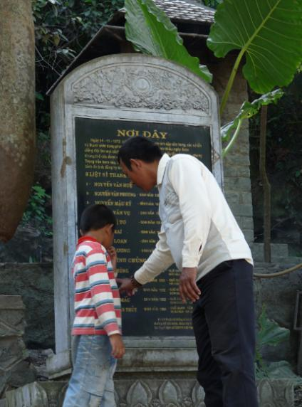

Visitors view a memorial at the Eight Heroic Volunteers Cave in
Phong Nha – Ke Bang National Park World Heritage Site.
    - Protecting and enhancing integrity

Management Objective
Ensure that the Park has sufficient size and contains all the necessary elements to demonstrate the key aspects of World Heritage geomorphological features and to maintain geological and ecological processes that are essential for the long term conservation of ecosystems and biodiversity, and contains all habitats in sufficient amount needed for maintaining the diverse fauna and flora characteristic of the Central Indochina Limestone Priority Landscape.

Background
Integrity and its maintenance is a key issue for all World Heritage Sites. It requires the property to be of adequate size to ensure the complete representation of features and processes which make up the outstanding universal values.

For integrity of World Heritage values under Criterion (viii), the area must contain all or most of the key interrelated and interdependent elements in their natural relationships, including the karst flora, and invertebrate and vertebrate fauna of caves and their ecological relationships. For heritage values included under Criterion (ix), the area must have sufficient size and contain all the necessary elements to demonstrate the key aspects of processes that are essential for the long term conservation of the ecosystems and the biological diversity they contain. For Criterion (x), the area must contain all habitats in quantities sufficient for maintaining the diverse fauna and flora characteristic of the bio-geographic province and the ecosystems featured in the World Heritage site.

Key to maintaining integrity of the World Heritage Site and the biological connectivity of its ecosystems is the need to counter pressures for unsuitable infrastructure development inside the Park. Tourism development needs to be designed with great care so as not to damage the integrity of any of the site’s World Heritage values or other values. Linear infrastructure, such as roads, power lines and cable ways, can be particularly disruptive to biological connectivity, cutting migratory routes and gene flow of fastidious species such as amphibians and gibbons.

There is currently an opportunity in the PNKB Region to capitalize on the support provided by foreign donors to establish appropriate and institutionalized mechanisms that encourage cooperation and appropriate management of lands adjacent to the Park. These adjoining lands could be managed not only to be compatible with protection of the Core Zone of the Park, but also to add value to the Park, improving its ecological security and promoting appropriate sustainable approaches to development in the Buffer Zone. This might be best achieved by adopting the Biosphere Reserve approach, a concept to which adjacent land managers could subscribe (see Annex XII).

Special attention is needed to protect the catchments of all of PNKB’s many underground rivers. The sources of several of these rivers lie outside the Park boundaries, and so are vulnerable to impacts of development, including siltation from land clearance, pollution from pesticides, herbicides and petrochemicals spills, and diversions and impoundments for hydroelectric or irrigation purposes. Any of these activities in the catchment could permanently damage PNKB’s World Heritage caves downstream.

Phong Nha - Ke Bang World Heritage Site and the Extension Area shares over 50 km of its boundaries with Hin Namno National Biodiversity Conservation Area (HNN-NBCA) in Lao PDR, increasing the integrity of both protected areas. Effective control of cross border illegal trafficking, however, is an essential condition for the stabilization of biodiversity status in both protected areas. Regular and functioning cross border collaboration between the authorities in Laos and Vietnam is therefore key.

Invasive alien species are a threat to the integrity of the WHS because they can prevent habitat regeneration and degrade natural habitats if uncontrolled. Campaigns to eradicate invasive species can be expensive and ineffective if not carefully planned and researched.

Fire represents a particularly pernicious threat to the integrity of PNKB’s forest ecosystems. Climate change has the potential to affect the integrity of the WHS in many ways, such as increasing the risk of fires. The World Heritage Committee has identified climate change as one of the most significant threats to World Heritage properties. Climate change is already affecting the Park. Monitoring local climate, anticipating possible impacts of climate change and planning responses will be key to adaptive management that can respond appropriately.

Desired Outcomes
- Connectivity, migratory routes and the intactness of large natural areas of the PNKB NP WHS managed, conserved, and retained for the conservation and benefit of native species.
  - Construction projects within the Park and near the Park are all subject to rigorous EIA that considers the World Heritage values of the WHS, implement effective mitigation plans, and do not cause any impacts on World Heritage biodiversity values in the Park over specified limits.
- Disturbed habitats in key areas restored and further disturbance prevented.
  - All tourism in the Park is ecologically sustainable and environmentally friendly.
  - The threat of invasive alien species in the Park is well understood and their spread is being controlled.
  - Wild fire is prevented or controlled; floods, windstorms and other natural disasters are anticipated and planned for, and research and planning have prepared the Park management for the potential impacts of Climate Change.
- Additional areas adjacent to PNKB NP WHS are brought under coordinated protective management to insure their essential ecological functions, such that watersheds and natural habitats of high conservation value are conserved.
  - All key areas upstream of the World Heritage underground rivers are placed under legal protection and effective management for conservation.
  - High conservation value habitats in the Buffer Zone are identified and conserved.
  - Vietnam and Lao PDR initialize a common knowledge base, sharing key available information about Hin Namno NBCA and PNKB NP.

Management Response
- Control construction of infrastructure, roads, buildings, etc.: Environmental Impact Assessment is required for all construction inside the National Park or that impacts the National Park. The Park Management Board will participate actively in the EIA development and review process.
- Strategic Plans for the Buffer Zone, such as Construction Master Plan and the Buffer Zone Development Plan, require Strategic Environmental Impact Assessment (SEIA) according to law. The Park Management Board will participate actively in the SEIA process and review the plans.
- Strengthen monitoring and management of invasive species and conduct research on prevention methods.
- EIAs ensure that constructions projects adopt measures to limit the introduction and spread of invasive species.
- Demarcate newly added areas and other key areas including certain functional sub-zones of the Park on the ground. With the participation of relevant government agencies and community leaders, the sites for boundary stones will be chosen at key locations on the boundaries of the Park. Clear, immovable markers will be erected. Informative signboards will be set up at all access points to the Park.
- Park leaders will lobby for gazetting key areas upstream of the Park’s underground rivers as Watershed Protection Forest, in which strict controls limit deforestation and water pollution.
- Strengthen transboundary cooperation with Hin Namno NBCA in Lao PDR, introducing mechanisms for regular cross-border operations that support effective biodiversity conservation and livelihood development, including joint information and knowledge management and improved environmental awareness and education on biodiversity.
- Awareness building, warnings, strict enforcement and serious penalties introduced to prevent carelessness with fire by visitors.
- Build fire awareness and develop capacity for prevention and response among communities, targeting communities from which the risk of fire spread to the Park is high.
- Support and train a fire prevention management board for the Park and consolidate joint fire prevention teams in key villages.
- Introduce climate monitoring constructing weather stations and a climate disaster database in the Park.
- Conduct vulnerability assessments of the National Park focused on its World Heritage values. Use scenario planning as a science-based decision-making framework.

Monitoring for this Objective will focus on threat reduction, forest cover and condition, and connectivity of habitat.

    - Appropriate presentation of heritage and tourism management

Management Objective
Ensure that the conservation of the Park’s important heritage values is supported through tourism development that emphasizes research, learning and awareness-raising about the unique natural and cultural heritage of the World Heritage Site, and the importance of the conservation of this heritage.

Background
All States Parties to the World Heritage Convention have the responsibility to ensure the appropriate presentation of the cultural and natural heritage identified within their territory, Presentation of the PNKB NP World Heritage Values should aim for the objectives above, while enhancing the function of World Heritage in the life of the community; and increasing the participation of local and national populations in the protection and presentation of heritage.

At its best, tourism can provide an outstanding opportunity to increase the understanding of natural and cultural heritage, while providing long-term financial support for site management, local communities and tourism providers. Poorly managed tourism on the other hand can pose major threats to World Heritage values and degrade the quality of the visitor experience. The State Party and its partners must ensure that use does not impact adversely on the Outstanding Universal Value of the property. For some sites human use would not be appropriate at all. All forms of tourism development in the PNKB NP WHS region must compliment, conserve and enhance the Park’s cultural and natural heritage values and must not detract from or diminish these values. Conservation of World Heritage values and other natural and cultural heritage values must be well supported by education, information and awareness raising efforts linked to, and supported by, tourism development and operations.

Tourism development throughout the PNKB Region must be sustainable in the sense that the overall quality and quantity of natural and cultural resources are maintained and enhanced, and natural processes for regeneration are not compromised. Tourism must also be sustainable in the sense that tourism products are of a high quality and provide a high level of satisfaction for visitors. Finally, quality tourism is only possible if tourism is also economically sustainable, so tourism products and activities developed must be assessed and approved based on sound market justification and financial operating capacity. Economic sustainability requires that reasonable profits to service providers are achieved, along with an equitable sharing of benefits and costs amongst relevant stakeholders and affected groups, including communities living in and around the PNKB NP WHS.

All caves in PNKB NP are part of its World Heritage values. Caves are particularly sensitive environments. Any damage to caves may be irreversible and should therefore be strictly avoided. Visitors inside caves must be carefully controlled and tourism development must be rigorously supervised in order to conserve the cave for future generations.

Desired Outcomes
- Tourism growth is monitored and supervised to ensure that it preserves the World Heritage values and other heritage values of the PNKB NP. Resource exploitation for tourism development is managed so that tourism is ecologically sustainable and environmentally sensitive.
- Tourism development is of a high standard and based on market research with equitable sharing of benefits. Tourism contributes to local economic development, particularly for the poor, and to sustainable livelihoods, maximizing opportunities for people living in the Park and Buffer Zone to effectively and equitably partake in tourism development, management, operations and economic benefits.
- Effective and efficient planning, management and operations of tourism reflects relevant higher-level policies and plans and are well integrated and coordinated with other relevant local development plans and activities.
- Tourism growth supports quality tourism experiences and a high standard of tourism products, receiving higher yields in economic returns per volume of visitors. Tourism growth is tailored to target markets and aimed to maximise economic return (yield) rather than sheer volume.
- Tourism growth contributes to an appropriate geographical spread of development where higher impact activities are concentrated in appropriate locations for effective management and lower impact activities that generate local benefits are suitably expanded throughout the region.
- Tourism growth uses management systems to control site visitor volumes to levels that do not compromise the World Heritage values and the ecological, historical and cultural integrity of the PNKB Region.

Management Response
- Referring to relevant guidance from the World Heritage Committee, the PNKB NP Management Board will work to ensure that design and management of National Park facilities available on site for visitors are appropriate in relation to the protection and management requirements of the WHS and its values, and that the facilities and services provide effective and inclusive presentation of the WHS to meet the needs of visitors, including in relation to the provision of safe and appropriate access.
- PNKB NP Management Board will design and initiate a comprehensive information and interpretation strategy to raise awareness of the Outstanding Universal Values and the other heritage values of the Park, and of the need to preserve World Heritage, and particularly to ensure that World Heritage status is adequately marked and promoted on-site.
- Design and produce engaging interpretation tailored to reach the various audiences that visit the World Heritage property, including day trip visitors, tourists, school children and local people, using appropriate materials (signage, trails, notices or publications, guides, etc.), and promoting the World Heritage status of the Park..
- Construct a visitor interpretation centre devoted to the PNKB NP WHS and presentation of its World Heritage Values.
- The PNKB NP Management Board will take a leading role in participating in tourism planning for the PNKB Region, reviewing all tourism plans, EIAs, SEIAs, concession agreements and leasing arrangements for tourism in the National Park (See Annex XIII for details of considerations to be reviewed).

Specific management prescriptions related to tourism will include the following:
- Organizational restructuring will institutionally separate tourism/visitor management and tourism operations in the PNKB NP to avoid conflicts of interest.
- The PNKB NP Management Board will carefully consider any tourism development proposals in the Park, drafting binding concession agreements between the PNKB NP and business sector operators for tourism activities in the PNKB NP.
- The PNKB NP Management Board will organize development of a complete Visitor Management Plan for the National Park (see Annex X for outline).
- Before opening any cave to visitors, a professional assessment study of the carrying capacity of the cave in terms of average and peak numbers of daily visitors, group size and frequency, permissible activities, etc., will be done by reputable cave experts.
- Site specific management planning will also be a requirement, including Identifying indicative visitor carrying capacity and setting up key management regulations. Management measures will comply with relevant IUCN and UNESCO international regulations and guidelines for World Heritage and for karst and caves.
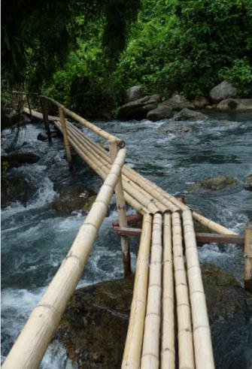
- Strict supervision of tourists in caves by PNKB NP WHS staff to protect caves and their features, and to ensure a safe and high quality visitor experience at all times.
- An environmental and social impact assessment and mitigation plan must precede any tourism development in the NP and particularly the opening of any cave to visitors. Such an assessment and plan should cover the environment inside the cave, the access roads, and other tourist facilities outside the cave.
- Supervision of all visitors and visitor groups by competent cave guides. In turn, cave guides will be supervised by PNKB NP staff for strict compliance to regulations and behaviour codes. Towards this end, the PNKB NP will organize a competency check and issuing of certifications, only allowing certified guides knowledgeable about cave protection and safety to lead groups into the caves.

Tourism will be monitored site specifically using the approaches of limits of acceptable change and the UNESCO World Heritage guidelines.

    - Addressing livelihoods issues

Management Objective
Ensure that areas in the Buffer Zone that are of high value for conservation of biodiversity and protection of World Heritage values are protected through development of alternative livelihoods and provide opportunities in the Park for buffer zone communities which do not jeopardize conservation, so as to gradually replace and halt harmful livelihood activities that create pressures on the heritage values of PNKB NP WHS.

Background
A few villages are located inside the National Park and World Heritage Site, while several others use land or resources from the Park for their subsistence or their income. Protecting and restoring the ecosystems, biodiversity and ecological will depend on controlling and reducing human use of natural resources.

Providing livelihood assistance and other benefits can reduce local dependence on unsustainable exploitation of natural resources and harvesting of protected species. Article 119 of the World Heritage Operational Guidelines states that World Heritage properties may support a variety of on-going and proposed uses that are ecologically and culturally sustainable and which may contribute to the quality of life of communities concerned. However, the government and its partners must ensure that such sustainable use does not impact adversely on the Outstanding Universal Values of the property. For most sites inside the World Heritage Site, human use involving harvesting would not be appropriate at all, so most activities for livelihoods improvement will occur in the Buffer Zone, outside the National Park.

Much of the current conflict between the National Park and local communities may have been created when the Park was formed and extended by grants of management authority over land and resources that were traditionally used by local communities and to which they may have had legal rights. Addressing the actual or perceived inequities created by this transfer of rights is a precondition to promoting and encouraging the cooperation and active participation of communities in the sustainable protection of the National Park and its World Heritage values.

By taking on a positive role in community economic development, the National Park can do much to defuse conflicts over resource and land use. According to Decree 117 and Decision 24, PNKB National Park management is responsible for formulating investment projects in the Buffer Zone and acting as their investor under law. The Park must involve local communities in these investment projects. The National Park can also link its investments in community development to forest protection, creating incentives for better forest management. The World Heritage Convention calls on all World Heritage Sites to promote and encourage the active participation of communities and stakeholders concerned with the property as necessary conditions to its sustainable protection, conservation, management and presentation.

The Buffer Zone of the PNKB NP Region is affected by a number of planning mechanisms, and its development and fate is not always under the direct influence of the Park Management Board. Even the Core Zone of the World Heritage Site may be affected by regional development plans that involve linear infrastructure or construction inside the Park. It is therefore essential that regional planning fully take into account the needs for protection of the World Heritage Site. Socioeconomic development in the region surrounding the National Park/World Heritage site must fully consider and accounts for the needs for protection of the World Heritage values, so as to fulfil Vietnam’s obligations under the World Heritage Convention. The Buffer Zone Development Plan and Sustainable Development Plan for PNKB NP region must be fully integrated with commune and district socio-economic development planning, construction plans and all plans for sustainable tourism development, and all of these plans must accommodate and support the protection of the World Heritage Site.

Desired Outcomes
- Legislations, policies and strategies affecting the PNKB World Heritage Site and Buffer Zone ensure the protection of the Outstanding Universal Values and support the wider conservation of natural and cultural heritage.
- Communities and stakeholders concerned with the property, and particularly those living in the greater PNKB NP Region, actively participate in its sustainable protection, conservation, management and presentation.
- Communities living in the Buffer Zone and inside the Park have alternative sources of income, and this reduces conflicts and decreases their incentives to participate in illegal logging, hunting and collecting NTFPs for market.
- Indigenous communities have sufficient sources of meat, medicines, and fuel to meet their needs, and this reduces their incentives to hunt, fish or collect NTFPs from the Park for subsistence needs.
- Grazing and clearance of forest for pasture and agriculture in and around the Park by villagers who are still dependent on these activities is reduced and controlled so that it does not damage the Park’s World Heritage Values.
- The Park shares benefits with local communities. In particular, tourism to the Park contributes to local economic development and sustainable livelihoods, particularly for the poor.

Management Response
- Provide alternative means of income generation that reduce dependence on natural resources and that are not damaging to the Park. This is a key goal of the Buffer Zone Development Plan. The exact means of income generation will be chosen as part of the participatory process used to develop Green Village Development Plans.
- Normalize the situation of those people who are living within the National Park by demarcating “internal buffer zones” within the Core Zone, with sufficient land for their current needs. Negotiate Forest Protection Contracts with these villages.
- Develop models of raising domestic animals: In key villages where availability of meat is a constraint to the end of hunting, the Park will provide extension training in raising domestic animals. For those activities implemented inside the Park, environmental assessment will insure that the project provides more benefit to protection than pressures on the Park’s resources.
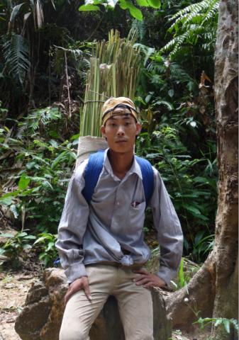
- Provide additional forest land to communities and encourage local people to manage and use their own forests sustainably: For key villages where lack of community forest land is a constraint to conservation, the project will promote Community Forest Management in State Forest Enterprises to increase the quantity and improve quality of timber that can be harvested.
- Support afforestation in key areas of the Buffer Zone to increase the sustainability of community forest use and increase the amount of land in forest adjacent to the Park.
- Plant high value trees: The market for high value timber from the Park is fueled in part by high prices resulting from scarcity elsewhere. The Park will promote indigenous knowledge in how to plant certain native high value timber species for those species that can be legally traded. (This activity must be accompanied by a strict and independently supervised certification scheme to prevent the “laundering” of illegally obtained timber.)
A Van Kieu minority person harvests palm leaves from Phong Nha – Ke Bang National Park World Heritage Site. Many local residents living in or near the Park depend on its resources for their livelihoods.
- Carry out a survey on NTFP use with NTFP user-groups in key villages within the Park and in the adjacent Buffer Zone area. On the basis of these surveys, develop sustainable harvesting plans for key NTFPs (but not for legally protected species).
- Based on the results of the NTFP surveys, and in consultation with villagers, draw up plans and maps for designated NTFP Exploitation Areas in the Buffer Zone, Administrative and Services Area and Ecological Restoration Area. (Exploitation in the Strictly Protected Area is not allowed by law).
- According to Decree 117 and Decision 24, the National Park management is responsible for involving people from buffer zone communities in managing the forests of the national park. This will be done through Forest Protection Contracts and Joint Protection Patrols with villages inside and adjacent to the Park.
- Create opportunities for people living in the Park and Buffer Zone to effectively and equitably partake in tourism development, management, operations and economies, through concession contracts that require local hiring, vocational skills training and transfer payments for forest ecological services (PFES) from tour operators or visitors.
- Provide and encourage vocational training, improvements in agro-forestry and small-scale industry, provision of seeds, breeding animals, equipment, supplies and funding, to support stable, long-term sustainable development.
- Supervision, monitoring and law enforcement to prevent deforestation, cultivation, animal grazing and other damaging activities inside the World Heritage Site.
    - Developing capacity and supporting management

Management Objective
Develop the managerial and professional capacity in forest protection and management, biodiversity conservation, forest fire prevention and control, tourism development and management for the National Park’s officers and staff and other stakeholders and support the equipment, funding, institutions and policies needed for the National Park Management Board to manage the heritage site well.

Background
Secure and uninterrupted support is vital to the success of a World Heritage site, and indeed to its very existence. Support must come in many forms; the support and participation of local communities, administrative and legislative support that creates an enabling legal environment for management, and dependable financial support that enable management to turn plans into reality.

Building the capacity and professionalism of the Park staff is also critical to effective implementation of all other management activities. Most of the staff of PNKB NP have been trained in Forestry or related fields and many have several years of experience. Managing a World Heritage site, however, confronts managers with challenges that require the skills needed to professionally manage an organization of over 200 staff and protect ecosystems and complex features that are dispersed in space across over 200,000 remote hectares. In addition to standard skills sets needed for adequate staff performance in any forest protected area, several special skills are needed for managing Natural World Heritage sites, related to the World Heritage Convention and protection of the Outstanding Universal Values.

Only if the organization is professionally managed in all its aspects can staff meet the targets for management of the National Park and the World Heritage Objectives. For this, a knowledge base accumulated through scientific monitoring and research is also an essential resource to guide management. Planning for sustainable financing is also a major need, to guide fund raising and also to make efficient and effective use of the funds obtained.

Desired Outcomes
- Support built among the public, scientists and leaders for protection of Phong Nha – Ke Bang National Park and conservation of its Outstanding Universal Values; Good habits fostered among local children, who feel pride in the Park, appreciate its values, , creating a bridge between the Park and their families,
- Skills, knowledge and attitudes needed for implementation of the Management Plan and routine management exists among the Park staff;
- Equipment, facilities and infrastructure needed for implementation of the Management Plan and routine management are available;
- Financial management and administrative processes needed for implementation of the Management Plan are in place in the National Park;
- Information needed for adaptive management is provided in a timely manner through monitoring and scientific research;
- Financial support needed for management and protection is available sustainably.

Management Response
Building support
- Set up an interpretation centre and displays at popular tourist sites, with the objective of raising awareness among visitors about the World Heritage values of the Park. creating interest and increasing enjoyment.
- Train tourist guides to increase their knowledge of the Park’s Outstanding Universal Values and other heritage values.
- Support local Conservation Clubs to organize study tours, camping, exhibitions, painting competitions, role playing, etc.
- Train for teachers using the World Heritage Educational Resource Kit for teachers: "World Heritage in Young Hands"
- Develop close cooperation between the Park and judiciary and build the political will for prosecution of forest and wildlife crimes.
- Lobby to raise understanding and support among decision-makers, with the focal message that "the Park has high value.”

Building skills and competencies
- Train staff of the National Park to support the activities in the Management Plan (See Annex XIII for more details.)
- Complete zonation and regulations of the Park, design and demarcate designated Plant Exploitation Sub-Areas and various tourism sub-areas; upgrade demarcation where needed.
- Develop a Patrolling Plan and Patrolling Manual with detailed measures for handling each type of violation specified.
- Training of community members in the Buffer Zone for sustainable management of community forests and NTFP exploitation zones, and fire prevention
- Extension training for local communities to support alternative incomes, alternative fuels and alternative livelihoods.

Building organizational capacities
- Operationalize a 5-year cycle of management within the Park based on the IUCN Framework, reviewing the context of existing values and threats, planning responses, allocating resources (inputs), implementing management actions (processes), recording outputs, and monitoring impacts and outcomes. Develop 5-year Operational Management plans by 2015, 2020 and 2025.
- Develop tactical level plans for Business Planning and Law Enforcement Management; and Operational Level Plans for Patrolling, Visitor Management, Cave Management, Community Outreach and Cooperation, Training, Monitoring and Research, and Annual Operational Work Plans.
- Procure equipment needed for implementation of the Management Plan and routine management.
- Construct infrastructure needed to improve working conditions and visitor services, including guard stations, an Interpretation Centre and a Botanical Garden.
- Establish and develop capacity and facilities so as to make PNKB a regional centre for scientific research that can strengthen domestic and international scientific research cooperation, hosting research expeditions, trainings and study tours.
- Carry out the routine professional financial management and administration needed for implementation of the Management Plan and management of the World Heritage Site.
- Revise the Strategic Management Plan for the PNKB region in 2025.

Monitoring, research and knowledge management for adaptive management

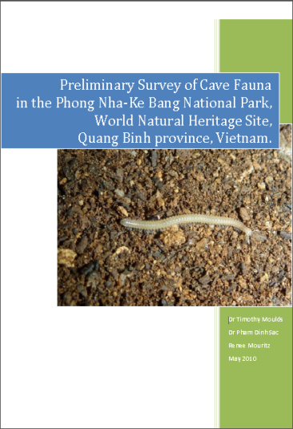
- Develop, test and review detailed monitoring protocols to ensure the quality and credibility of information.
- Repeat the METT assessment with full participation of Park staff and begin using the Enhancing our Heritage (EoH) Toolkit in 2013, repeating the process every 5 years.
- Design, establish and maintain a database to record details on all violations in the Park.
- Repeat the participatory Threat Reduction Assessment every year.
- Monitor tourism following UNESCO guidelines and complete the UNESCO Periodic Reporting every year.
- Monitor impacts of Management Action on reducing poaching of protected species by tracking indices of key indicator species using transects, fixed plots and camera traps, as well as the indices of numbers of traps and snares in a fixed plot and numbers encountered per kilometer by patrollers.

Phong Nha – Ke Bang National Park World Heritage Site could become a global hotspot for research on karst and caves.

- Monitor impacts of Management Action on reducing illegal logging with repeated forest resource inventory in fixed plots and through satellite image interpretation.
- Monitor collection of NTFPs and fire wood by interviewing harvesters (focal group surveys) to track change in harvest per day of effort.
- Monitor tourism impacts, tracking water pollution, solid waste and noise pollution at popular tourist sites.
- Monitor tourism impacts on cave micro climate and CO² concentrations at tourist caves. Implement photo-monitoring to track damage to speleothems.
- Closely monitor all construction projects inside the World Heritage property to track compliance with mitigation plans and short-term and long-term impacts to heritage values.
- Monitor invasive species in fixed plots, beginning with inventory of selected invasive species in key areas where this has been identified as a problem.
- Develop and implement a plan for scientific and technical studies and research on operating methods to counteract the dangers that threaten the Park’s natural and cultural heritage.

Sustainable financial support
- Prepare and track annual operational workplan budgets.
- Draw up sustainable financing strategies for management and engage in business planning, based on Business Planning for Natural World Heritage Sites – A Toolkit.
- Plan for and participate in various proposed Payment for Ecological Services schemes for transfer of payments from: tourism operators, visitor fees, downstream water users and REDD+ carbon credits, etc., both to the National Park/World Heritage site and for support of relevant activities in the Buffer Zone.
- Organize corporate sponsorships and solicit support from ODA and charitable foundations.
- Prepare to fully implement Decision 24, piloting the investments in selected villages, and eventually applying for all eligible villages in the Buffer Zone.

Monitoring for this Objective will utilize the Management Effectiveness Tracking Tool and Enhancing Our Heritage Toolkits.

SELECTED REFERENCES

Anon. (2008) Greater Blue Mountains World Heritage Area Strategic Plan. Department of Environment and Climate Change (New South Wales); Sydney. 58pp.

Apel, U., Maxwell, O.C., Nguyen Trong Ninh, Nurse, M., Puri, R.K. and Trieu Van Co (2002) Collaborative Management and Conservation: A Strategy for Community Based Natural Resource Management of Special Use Forest in Vietnam. Fauna & Flora International/World Bank; Cambridge, UK. (Summary in Vietnamese).

Appleton, M. R., Texon, G.I. &Uriarte, M.T. (2003) Competence Standards for Protected Area Jobs in South East Asia. ASEAN Regional Centre for Biodiversity Conservation: Los Baños, Philippines. 104pp.

Hockings, M., Stolton, S., Leverington, F., Dudley, N. and Courrau, J. (2006) Evaluating Effectiveness: A framework for assessing management of protected areas, (2nd edn) World Commission on Protected Areas, IUCN; Gland, Switzerland.132 pp.

Hockings, M., James, R., Stolton, S., Dudley, N., Mathur, V., Makombo, J., Courrau, J. and Parrish, J. (2008) Enhancing our Heritage Toolkit: Assessing management effectiveness of natural World Heritage sites. UNESCO World Heritage Centre; Paris, France.

Intergovernmental Committee for the Protection of the World Cultural and Natural Heritage (2011) Operational Guidelines for the Implementation of the World Heritage Convention. Heritage Centre: UNESCO World Heritage Centre: Paris. 173pp.

Pedersen, A. (2002) Managing Tourism at World Heritage Sites: a Practical Manual for World Heritage Site Managers, World Heritage Paper No. 1, UNESCO, World Heritage Centre, Paris 2002.

Stolton, S. Dudley, N. and Shadie P., coordinating authors (2012) Managing Natural World Heritage. UNESCO / ICCROM / ICOMOS / IUCN, 2012. 101pp.

Toomey, R.S. (2009) ‘Geological monitoring of caves and associated landscapes’, in Young, R. and Norby, L. Geological Monitoring, Geological Society of America; Boulder, Colorado pp 27-46

Williams, P. (2008). World Heritage Caves and Karst. IUCN: Gland, Switzerland. 57pp.
UIS Department of Karst and Cave Protection (2012) Recommended management guidelines for show caves. In litt.6 pp.

ANNEXES

- Brief history of Phong Nha- Ke Bang National Park

The area of today’s PNKB NP has been a place of note since the 1920s when the Phong Nha Cave was first discovered and visitors started to travel to the area. In 1937, the Bureau of Tourism of the French Resident Superior in Hue issued a brochure to introduce tourists to Quang Binh Province and the Phong Nha Cave. During periods of war, the forests and caves around the PNKB NP area in general and the Phong Nha Cave in particular were used as military quarters and weapon storages by the Vietnamese Army. PNKB NP and the area surrounding the National Park were also an important transport corridor for goods and for supporting military operations. A key route of the Ho Chi Minh Trail travels along the current National Park borders. National Road 20, which was an important access route to Lao PDR during the war, crosses the National Park property.

After the periods of war, local authorities organised and carried out surveys to protect the region around PNKB. In 1986, a strictly protected forest area in PNKB was established with an area of 5,000 ha. More people began visiting the area and in 1990 the first guesthouse was built at Xuan Son Ferry offering the first boat tours to Phong Nha Cave. In 1993, the PNKB Nature Reserve was established with an area of 41,132 ha and in 2001 the Vietnamese Government issued a Decision to upgrade the PNKB Nature Reserve to the PNKB NP. In 2003 the PNKB NP was officially listed as a UNESCO WHS. An extension to the National Park land was granted in 2008 which included 31,070 ha of land in the area of Thuong Hoa and Hoa Son communes (Minh Hoa District).

Table 1 and Map 1 provide a summary of functional zones of the PNKB NP WHS and communes in the Buffer Zone as of 2012.

Table 1: Land area of Phong Nha – Ke Bang National Park Region Region

Sub-zones | PNKB Core Zone (ha) | PNKB Buffer Zone (ha)
Strictly Protected Area inside World Heritage property | 68,894
Strictly Protected Area outside World Heritage property | 37,572
Ecological Restoration Area (also in World Heritage property) | 17,449
Administrative and Service Area (also in World Heritage property) | 3,411
Total Area | 123,326 | 221,200
Total Area in the PNKB Region | 344,526

- Recognized World Heritage Values: Geomorphology and Earth history

World Heritage values are outstanding universal values that are directly related to the criteria for which an area is included on the World Heritage List. PNKB National Park World Heritage Site was inscribed on the World Heritage List in 2003 because it satisfies one of the criteria for natural values of outstanding universal significance as an outstanding example representing major stages of earth's history, including significant on-going geological processes (World Heritage Criterion viii).

Phong Nha displays an impressive amount of evidence of earth history. It is a property of very great importance for increasing our understanding of the geologic, geomorphic and geo-chronological history of the region. Phong Nha is part of a larger dissected plateau, which also encompasses the Ke Bang and Hin Namno karst (in Lao PDR). The plateau is probably one of the finest and most distinctive examples of a complex karst landform in Southeast Asia. The karst formation of Phong Nha-Ke Bang National Park has evolved since the Paleozoic (some 400 million years ago) and so is believed to be the oldest major karst area in Asia. Subject to massive tectonic changes, the park’s karst landscape is extremely complex with many geomorphic features of considerable significance. The vast karst area, extending across the border into the Lao People’s Democratic Republic, contains spectacular formations including over 104 km of caves and underground rivers, making it one of the most outstanding limestone karst ecosystems in the world.

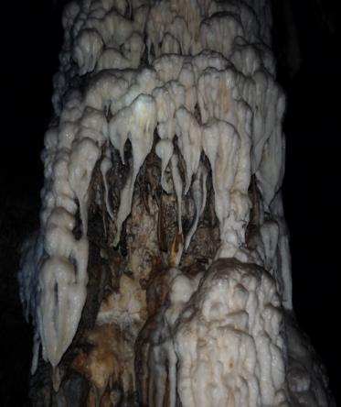
The karst formation processes have led to the creation of a variety of cave types on the property, including underground rivers, dry caves, terraced caves, suspended caves, dendritic caves and intersecting caves. The centerpieces of the site are the Phong Nha Cave, through which an underground river flows 44.5 km, and Paradise Cave, recently opened to the public. The Park protects the Son Doong Cave, believed to be the world’s largest dry cave. These and the hundreds of other caves discovered to date demonstrate discrete episodic sequences of events, leaving behind various levels of fossil passages, formerly buried and now uncovered karst from previous, perhaps very ancient, periods; evidence of major changes in the routes of underground rivers; changes in the solutional regime; and other unusual features.
A speleothem in the undeveloped portion of Paradise Cave.

- Potential World Heritage Values: Evolutionary Processes and Biodiversity

Phong Nha-Ke Bang NP WHS has other outstanding values that have the potential to qualify for World Heritage listing in their own right.

On-going Evolutionary Processes: PNKB should be globally recognized as an outstanding example of significant on-going ecological and biological processes in the evolution and development of terrestrial, fresh water, and subterranean ecosystems and communities of plants and animals (World Heritage Criterion ix).

PNKB National Park protects a large portion of one of the best preserved tracks of limestone forest in the central Truong Son range (Annamites), which has been recognized as a critical landscape of the Greater Annamites Global 200 Bioregion. Many endemic and near-endemic vertebrates are associated with this ecoregion, which has been identified as one of the greatest concentrations of endemic species in a continental setting found anywhere. PNKB NP is a key protected forest within the Central Indochina Limestone Priority Landscape (NA6), which is ranked as globally critical for biodiversity conservation. It hosts numerous limestone specific taxa, including a number of Annamite endemics–more so than the Northern Indochina Limestone Landscape (NA1), - making the Central Indochina Limestone the most extensive limestone area holding the most distinctive limestone community in the Greater Annamites Ecoregion. This area is critical for the conservation of primate species and limestone specialist species.

Of particular note are several primitive or relict species that have been recently discovered in PNKB which have few or no close relatives, including the Saola (Pseudoryx nghentinhensis), Annamite Striped Rabbit (Nesolagus timminsi), and Laotian Rock Rat (Laonastes aenigmamus). The last of these, in particular, has been identified as a ‘Lazarus species’, the only representative of a lineage (Diatomyidae) that was previously only known from fossils that date to at least 11 million years bp. The persistence of more primitive or relict species such as these could be attributed to long-term habitat stability in the region, the effect of a stable climate and of regular uplifts over a long period maintaining a suitable distribution of habitat types.

“Although it is difficult to quantify rates of endemism and compare them among areas and groups of organisms, these observations suggest that central Vietnam’s uplands and associated lowland areas may be a focal point or hotspot of endemism within mainland Southeast Asia. If true, a possible explanation is that the Truong Son Range remained climatically and ecologically stable as the surrounding forests and other habitats contracted, expanded, or turned over during long-term climate fluctuations. Its forests may have served as refuge for forest-dwelling species during cooler, drier periods when their evergreen forested habitats disappeared from lower elevations. Under these long-term, stable conditions, older species were preserved and the evolution of new species may have been facilitated.”

Several ongoing evolutionary processes may have resulted in the high rate of endemism and unusual faunal features of PNKB: The development of a stable, warm tropical high rainfall monsoon weather system since the Pleistocene cold period may have accelerated evolutionary development within the karst landscape. Many endemic taxa found in the Park, such as the two similar langurs - the Hatinh Langur (Trachypithecus hatinhensis) and the Indochinese Black Langur (T. ebenus), have overlapping but distinct range boundaries. This patchy distribution may be due to climatic, geographic, or ecological barriers, or interspecific competition that prevented effective dispersal out of the patches. It could also be that these taxa have not yet recolonized other areas since the last glacial maximum 18,000 years ago, even though they may be capable of doing so. The episodic uplift of the limestone landscape from (at least) the Tertiary and the successive karst development, rejuvenation and ongoing evolutionary karst development has created specialist habitats. These specialised habitats that have fostered evolutionary development in the karst landscape continue to exist, including within caves (troglobitic species), at cave entrances (cave nesting volent vertebrates and the invertebrate communities that they support; low light specialist vegetation species), and within dolines (refugia for relict types dependent on the high humidity and colder air temperatures generated by caves).

Cave fauna in particular show the striking effect of isolation on species divergence. A preliminary study of the cave fauna from the PNKBNP WHS found at least 41 species of invertebrates among 248 individual specimens collected from the three cave systems surveyed. Only five species were common across the three caves. The discovery of two species of blind scorpions in PNKB is highly significant, as there are currently only about 20 described cave dwelling scorpions in the world that exhibit troglomorphic characteristics. The new species, Vietbocap thienduongensis and V. canhi, were the first troglobitic scorpions found in mainland Asia.

Biodiversity: PNKB NP WHS should also be recognized for its global importance in in-situ conservation of biological diversity, including species of outstanding universal value from the point of view of science or conservation (World Heritage Criterion x).

The PNKB NP WHS property is of global significance for the conservation of biodiversity because its forest ecosystems, both karst and non-karst, support a high diversity of plants and animals, including a number of karst specialist species, many endemic species and a number of species that are globally threatened. Its rich diversity of endangered species still includes large mammals such as Asiatic Black Bear (Selenarctos thibetanus), Malayan Sun Bear (Ursus malayanus), Binturong (Arctictis binturong), Large-antlered Muntjac (Muntiacus vuquangensis), Saola (Pseudoryx nghentinhensis), Gaur (Bos gaurus, a small population of which still exists immediately south of the Park), and Tiger (Panthera tigris, of which there are recent provisional unconfirmed records from the Park). Living in PNKB specifically are many endemic and restricted range species, including charismatic representatives such as the Red-shanked Douc (Pygathrix nemaeus), Southern White-cheeked Gibbon (Nomascus siki), Large-antlered Muntjac (Muntiacus vuquangansis), Crested Argus Pheasant (Rheinardia ocellata), and Annam Flying Frog (Rhacophrus annamensis).

PNKB supports four of seven restricted range species of the Annamese Lowland Endemic Bird Area. The Park’s fauna includes a number of recently discovered karst endemics, including vertebrates such as Hatinh Langur (Trachypithecus hatinhensis), Sooty Babbler, (Stachyris herberti), Bare-faced Bulbul (Pycnonotus hualon) and Limestone Leaf-Warbler (Phylloscopus calciatilis). Of particular note is a ‘Lazarus taxon’: the Laotian Rock Rat (Laonastes aenigmamus), which is the only living species in a family that disappeared from the fossil record for 11 million years but was recently rediscovered by science.

The limestone forest ecosystem at Phong Nha-Ke Bang supports a high diversity of plant species as well. Of perhaps the greatest conservation significance are several species found at the site that are endemic to this part of central Vietnam and Laos. The site supports 419 plant species that are endemic to Vietnam. In addition, one genus and nine species were recently discovered that all appear to be new for science (Avervanov et al. 2011).

Almost 94% of the PNKB NP WHS property is forested, and 84% of this is old-growth forest. The property is also recognized as part of a Global 200 priority ecoregion, an Indo-Burma global biodiversity hotspot and an Endemic Bird Area that is not otherwise represented on the World Heritage List. The Park hosts more than 2,851 species of vascular plants, including 419 that are endemic to Vietnam, and 755 species of vertebrates, of which 69 are globally threatened. As of 2012, 12 species of plants recorded in the Park were considered globally Critically Endangered, and 11 were globally Endangered, The Park possesses 39 mammals that are included in the IUCN List of globally threatened species. Seven of the nine primate species occurring in the park are globally threatened, and the Park is the most important refuge for three of them. The Park probably has the largest remaining populations of the globally endangered Southern White-cheeked Gibbon and Hatinh Langur, a primate that is specialized for karst forest and is endemic to Vietnam and Lao PDR.
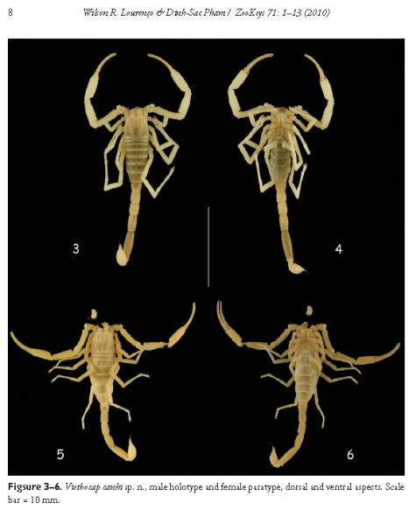

A figure from the formal describption of a new species of blind cave scorpion, one of many new species recently discovered in Phong Nha – Ke Bang National Park World Heritage Site. The Park is a natural laboratory for the study of evolutionary and ecological processes.

- Other Heritage Values

Apart from the features which are recognized as having World Heritage value, PNKB has numerous other outstanding values that complement and interface with its World Heritage values. Protection of all of these values is an integral part of managing Phong Nha - Ke Bang National Park WHS and the greater Phong Nha-Ke Bang region.

Historic Values
PNKB NP WHS includes numerous places of great historic significance. In addition to a long history of human occupation, PNKB became a key theatre during the US-Vietnam War. The Ho Chi Minh trail, including Road 20 to Lao PDR and associated trails in and near the Park, were key transportation routes for the war effort. In some ways, this is where the outcome of the war was decided.

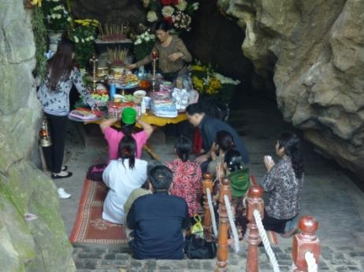
During periods of war, the forests and caves around the PNKB NP area in general and the Phong Nha Cave in particular were used as military quarters, weapon storage depots, shelters, theatres, and hospitals by the People’s Army of Vietnam. PNKB NP and the area surrounding the National Park were an important transport corridor for goods and for supporting military operations during the US-Vietnam War. Key parts of the Ho Chi Minh Trail traveled along the current National Park borders, and Road 20, which became the key to a critical by-pass route through Lao PDR during the war, crosses the National Park property. Through heroic efforts, these critical transport routes were maintained in the face of “a campaign of air interdiction that dwarfs anything in military history before or since.” Quang Binh Province is said to have the distinction of having been one of the most bombed areas on earth. In mid-1965 the number of bombing sorties being flown here reached a peak of 1,000 sorties per month. Maintaining the transport of men and materials from north to south, despite this all-out effort by a far greater military power, was key to the eventual success of the People’s Army of Vietnam from the north and the National Front for the Liberation of South Vietnam in the south. More than just a supply route cut through the heart of Indochina, the Ho Chi Minh Trail was in essence the heart of the war efforts. According to the United States National Security Agency's official history of the war, the Trail system was "one of the great achievements of military engineering of the 20th century…"
Pilgrims pay their respects to the war dead at the Eight Heroic Volunteers Cave in Phong Nha – Ke Bang National Park World Heritage Site.

Historical sites in the PNKB NP WHS include:
- Phong Nha Cave, which was an important military quarters and hospital during the war, The Phong Nha Cave is the iconic site for the region. The cave has become a high volume, mass tourism site, currently receiving approximately 250,000 visitors per year. In the high season visitor numbers can easily exceed 2,000 in a day.
- The Eight Heroic Volunteers Cave and nearby Nurses’ Cave are important spiritual and historical sites inside the PNKB NP on Road 20. The Eight Heroic Volunteers Cave, where volunteers were buried alive during a bombing raid, together with the Nurses’ Cave have taken on great significance as memorial sites for all the sacrifices made during the war. They have become pilgrimage destinations for all Vietnamese and for veterans from both sides of the former conflict. The Eight Heroic Volunteers Cave is a high volume tourism site and it has been estimated that more than 150,000 visitors travel to this site each year.
- Victorious Road 20 and the Ho Chi Minh trail network are important historical routes that played key roles in the US-Vietnam War. The Ho Chi Minh Highway West is the only portion of the Trail in the Park that is now paved, and it has become a popular scenic route for bikers. Other sections of the Trail network remain undeveloped, and still present the visitor with the experience of these rough wartime troop and supply routes, climbing up and down the karst hills, hidden from the bombers by a dense forest canopy.
- The Ho Chi Minh Museum is planned at the junction of the Ho Chi Minh Highway and Victorious Road 20 in the PNKB NP. The Museum will present the historical significance of the region, and is planned to be of regional and national historical importance.

Indigenous Culture and Cultural Diversity
Phong Nha - Ke Bang area was inhabited for centuries. Champa inscriptions have been found inside caves in the park, including Phong Nha Cave.

The Park and Buffer Zone together have a population of over 62,000 people in 13 communes. The majority ethnic group is Kinh, but there is a significant proportion that follow the Catholic faith and traditions introduced by European missionaries beginning in the 17th century. The total population also includes 19% ethnic minorities, belonging to the Bru-Van Kieu group (including Van Kieu, Khua, Macoong and Tri sub-groups) and Chut group (including Sach, May, Ruc, Arem and Ma Lieng sub-groups). Most ethnic minority communities inhabit the more remote, steeper parts of the Buffer Zone. Today, approximately 11,000 inhabitants of the Phong Nha - Ke Bang region are from ethnic minorities.

As of 2012, there were two ethnic minority groups with 78 households and 444 peoples living in the Core Zone of the PNKB NP, with about 150-200 ha of agricultural land. Until the 1990s, the Arem people lived in caves inside what is now the Park, but they have been resettled in village No. 39 of Tan Trach Commune which is located along the National Road 20 near the Western border of the National Park. The Van Kieu people have settled in Doong Village in Tan Trach commune located near the Southern border of the National Park.

The cultural traditions of the Arem, Van Kieu, Ruc and other minority people living in the PNKB region are still apparent there, but are at great risk of being lost. Indigenous people have lived in the area for hundreds of years, and much of their traditional way of life is linked with the use of natural resources from the forests of Phong Nha- Ke Bang. These communities still retain significant indigenous knowledge about the caves, the forest and the uses of its species.

Recreation and Tourism
PNKB has outstanding recreational values because of the intrinsic beauty of its caves and of the forested karst landscape, all easily accessible from major population centres in Vietnam. PNKB provides opportunities for quality recreation and tourism experiences that are increasingly in demand, and rare by world standards.

PNKB NP WHS offers a wide range of recreational opportunities, and is receiving increasing attention from both national and international visitors. The Park contains a wealth of potential tourist attractions and offers abundant recreational opportunities, many of which have national or regional significance because of their rarity elsewhere. Among the many sites open to tourists, three notable sites have already been developed and are exceptionally popular:

Phong Nha Cave is a water cave and the feature attraction of the PNKB NP Region. It is located in the administration and service area approximately 30 minutes by boat from Phong Nha Township center. It is usually accessed by rented boats operated by local people. Phong Nha became a place of note in the 1920s when the Phong Nha Cave was first discovered and visitors started to travel to the area. Since the periods of war, and especially since the designation of PNKB as a World Heritage Site in 2003, Phong Nha Cave has become a high volume/mass tourism site. The cave received approximately 250,000 visitors in 2010, and in the high season visitor numbers can easily exceed 2,000 in a day. The Phong Nha Cave is the iconic site of the region and the vast majority of the visitors visit the cave during their stay.

Paradise Cave (Hang Thien Duong) presents an outstandingly beautiful collection of speleothems and cave features of many types that are still very well preserved and in an original state. The entrance to the cave is in the Ecological Restoration Area of PNKB NP, about 70 km northwest of Dong Hoi and 4.7 km west of the West Ho Chi Minh Highway. The cave has already demonstrated high potential as a stand-alone tourism product and as

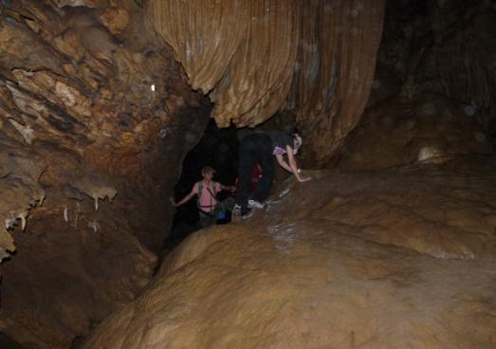

Adventure tourism in the wild portion of Paradise Cave. Phong Nha – Ke Bang National Park
has vast untapped tourism potential for adventure tourism, nature tourism and cultural tourism.
a very exclusive adventure tourism product. Truong Thinh Corporation, which has invested to develop tourism at the site, is the first private enterprise permitted by Quang Binh Province to invest in tourism development in the Park.

The Eight Heroic Volunteers Cave is an important spiritual and historical site inside PNKB NP WHS. It is easily accessible through the road network inside the PNKB NP, located on National Road 20 about 40 minutes driving from Phong Nha Township. The Eight Heroic Volunteers Cave is very popular with domestic visitors and is managed as a high volume tourism site. In 2010, it was estimated that 150,000 visitors travelled to this site in one year, and the numbers are probably much more today.

Social and Economic Values
The regional economy surrounding PNKB is receiving increasing support from tourism. The Park has considerable social and economic value and contributes directly and indirectly to employment, to income and to revenue in the region. Visitation to PNKB Park is growing rapidly, reflecting the Park’s increasing importance as a destination for both day trips and longer stays.

The noticeable growth in visitors to Quang Binh Province over recent years can be attributed largely to the UNESCO WHS listing of PNKB NP. Visitation to the PNKB NP Region has increased considerably recently from approximately 80,582 in 1999 to over 366,753 in 2011. Although there is no comprehensive estimate of the economic value of this visitation, in 2011 the government of Quang Binh Province reported receipt of 24.5 billion Vietnamese Dong (about $1.2 million USD) in total tourism revenue from PNKB NP entrance tickets and service taxes. The Park and associated tourism operations have also been taking on an increasing role in providing quality employment to local people in what is otherwise a poor area entirely dependent on forestry and traditional agriculture.

Research and Education
The complexity of its geomorphology and the richness of its biodiversity and ecosystems make the PNKB NP WHS an ideal area for research and education.

Information arising from scientific research and exploration conducted so far were the basis for the World Heritage nomination, however, current knowledge about the World Heritage values of the Park is far from complete. The high scientific value of the Park reflects not only what has already been discovered, but also what remains to be discovered. Further research and exploration is a critical need. Large gaps in knowledge remain, particularly that needed to better understand the geological and biological processes that gave rise to the spectacular geomorphology of the area and the outstanding and unique biodiversity.

Since many species, communities and geological phenomenon are found only in this region, there will certainly be ongoing scientific interest in PNKB. This interest should be fostered, since effective management of the Park relies on adequate understanding of its resources and the threats that they face. Allowing and facilitating relevant scientific research is directly related to one of the obligations under the World Heritage Convention to encourage scientific research into the identification, conservation and rehabilitation of the World Heritage Site’s Outstanding Universal Values, as well as to foster best management processes and abatement of threatening processes.

The educational value of PNKB is heightened by its accessibility to many institutions of higher learning, particularly universities in Hue and Dong Hoi. The Park’s Center for Scientific Research, which manages a botanical garden and wildlife rescue center, is a foundation on which to develop and implement a collaborative, interdisciplinary and strategic approach to research and education in the region.

Scenic, Aesthetic, Inspirational and Existence
The dramatic karst landscape of PNKB World Heritage Site provides a scenic landscape of extraordinary beauty full of inspiring wonders.

The stunning spectacle of PNKB’s caves has attracted visitors since the earliest days of modern tourist activity in Vietnam. The breath-taking beauty, magnificent size and awe-inspiring age of its cave formations; the rugged landscapes with row on row of karst mountains receding into the distance; the verdant green vegetation of its old-growth forests abounding with species, many of them yet to be discovered; the solitude of its foot paths and streams; All in all, a visit to PNKB NP WHS can be an experience of the sublime. These and other attributes of PNKB excite a sense of wonder and also promote serenity and reflection in the minds of visitors. Such feelings are valued by individuals and society, inspiring writers, painters, photographers and other artists to create, and rejuvenating the human mind, battered by a crowded, busy modern world.

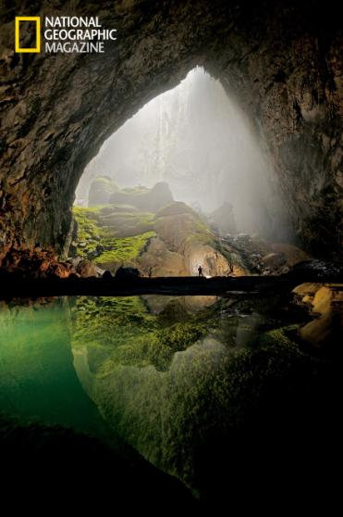
Looking down from a scenic overlook on the vast karst landscape covered with old-growth forests and knowing that there are gibbons and monkeys in those trees somewhere and that a tiger may still prowl the forest floor below is inspiring, even if most visitors will never see these animals in the wild. The massive size and unexpected wonders of Son Doong Cave, known as the world’s largest cave, have inspired millions of people all over the world through the media of photography and video. There is pleasure in knowing that places such as this exist and are protected, even though we may never be able to visit them. The value that society ascribes to this pleasure is technically called existence value. Simply knowing that wonders such as these exist and are protected forever is a value for many people throughout the world, even among those who may never be fortunate enough to visit the WHS.

The entrance to Son Doong Cave. Closed to tourists, the cave has been seen by millions of people through photographs and video.
Photo: Carsten Peter through National Geographic.

- Institutional Framework

The Provincial People’s Committee (PPC) of Quang Binh has the highest level of authority and responsibility for managing and monitoring activities in the PNKB NP Region. PNKB NP Management Board has direct responsibility for managing the National Park and World Heritage Site. It is a unit directly under the PPC of Quang Binh. The most relevant Departments in the PPC include the Department of Culture, Sports and Tourism, the Department of Planning and Investment, and the Department of Agriculture and Rural Development.

The institutional framework for management and monitoring of the PNKB NP Region is described as follows:
- The Department of Planning and Investment has the responsibility to advise the Provincial People’s Committee for directing the investment and implementation of infrastructure plans and activities delivered at the District and Commune levels.
- The Department of Agriculture and Rural Development through its Provincial Forest Protection Department have the responsibility for monitoring activities of forest resource management in both the Core Zone and Buffer Zone.
- The Department of Natural Resources and Environment has the responsibility for monitoring activities of land, rock, karst, mine and water resource management in the Park and surrounding region.
- The Department of Science and Technology has responsibility for monitoring activities relevant to science and technology in the Park.
- The Department of Culture, Sports and Tourism has responsibilities for monitoring activities relevant to cultural conservation and development as well as tourism in both the Core Zone and Buffer Zone.
- District Forest Protection Departments have responsibilities for monitoring activities of forest management and protection in the Buffer Zone. The National Park has its own Forest Protection Department with the same responsibility for the Core Zone.
- The Department of Police has responsibility for all law enforcement in the Buffer Zone and Core Zone.
- The regional military authorities have responsibility for patrolling the international border.
- District Peoples’ Committees (DPC) and Commune Peoples’ Committees (CPC) have responsibilities for cooperating and mobilising local people to participate in forest protection in both the Core Zone and Buffer Zone.
- Communities in the Core Zone and Buffer Zone are able to participate in monitoring activities of natural resource management in their areas.

- Organisation and management

The PNKB NP has a management board with one director and two vice-directors and is organised in three units (Scientific Research and Rescue Centre, Cultural and Eco-tourism Centre, National Park Forest Protection Unit) and two functional offices (Administration – Organization and Planning - Finance). It is planned that the Cultural and Eco-tourism Centre will be reorganized as a joint-stock company partly owned by .

The PNKB NP currently employs a total of 220 state officials and civil servants. According to a restructuring proposal submitted for approval in 2012, the future organization will include an Executive of a Director and 3 Vice-Directors, a National Park Forest Protection Unit with 254 permanent staff for protection and management of natural resources of the PNKB NP, the Centre for Conservation, Rescue and Development of Living Organisms with 27 permanent staff involved in rescuing and displaying wildlife and plants, a Unit for Scientific and International Cooperation with 10 fulltime staff for scientific research, an Administration and Organization Unit with 18 fulltime staff, and a Planning and Finance Unit with 8 fulltime staff. Finally, the National Park Management Board currently supervises the Phong Nha – Ke Bang Tourism Centre which has 137 permanent staff who are tasked with sustainable management and development of cultural, geological and ecological values and presentation and promotion of the heritage values of PNKB NP. It has been proposed that the Tourism Centre will become a joint-stock company, co-owned by the National Park and private investors. If this comes to pass, the protection functions of the Tourism Center (guards in the caves and at other sites) should be turned over to the National Park.

Figure 3 illustrates the organisational structure of the PNKB NP

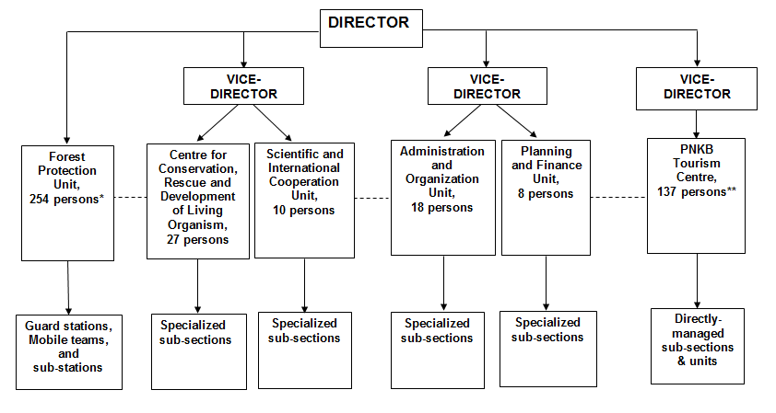

* Quota to be filled.
** Reorganization into a joint-stock company may be pending.

- Human Population

Average population density of the communes in the Buffer Zone of Phong Nha – Ke Bang NP is low (19.0 people/km²), however it is unequally distributed among communes. The communes with high population density are Phuc Trach (178.7 people/km²), Hung Trach (116.7 people/km²) and Son Trach (105.1 people/km²). Meanwhile, the communes of Thuong Trach and Tan Trach have very low population density, with 3.39 and 1.22 people/km² in respective, but all 443 people living in Tan Trach live inside the National Park and World Heritage Site.

Table 2: Overview of Population of the Buffer Zone communes in 2011
District | Commune | No of people | Natural land area (ha) | No of people in the Park | Population density (people/ km2)
Bo Trach | Hung Trach | 11104 | 9515.0 |  | 116.7
Bo Trach | Phuc Trach | 10761 | 6022.4 |  | 178.7
Bo Trach | Son Trach | 10653 | 10138.7 |  | 105.1
Bo Trach | Tan Trach | 443 | 36281.0 | 443 | 1.2
Bo Trach | Thuong Trach | 2461 | 72572.5 |  | 3.4
Bo Trach | Phu Đinh | 2719 | 15360.2 |  | 17.7
Bo Trach | Xuan Trach | 5727 | 17716.9 |  | 32.3
Minh Hoa | Trung Hoa | 5751 | 9453.9 |  | 59.7
Minh Hoa | Dan Hoa | 3491 | 17652.0 |  | 19.8
Minh Hoa | Trong Hoa | 3568 | 18885.2 |  | 18.8
Minh Hoa | Hoa Son | 1616 | 18030.7 |  | 9.0
Minh Hoa | Thuong Hoa | 3168 | 35470.0 |  | 8.9
Quang Ninh | Truong Son | 4021 | 77427.9 |  | 5.2
Total |  | 65483 | 344526.3 | 443 | 19.0

Source: Statistical Yearbooks of districts, 2011

Ethnic minority people
The ethnic minority people living in the Buffer Zone and Core Zone of the National Park belong mainly belong to the Bru - Van Kieu ethnic minority group (including Van Kieu, Khua, Ma Coong and Tri sub-groups) as well as Chut (Ma Lieng, May, Sach, Ruc, and Arem sub-groups). About 22.31 percent of the population of the Buffer Zone belongs to ethnic minorities. Table 3 shows the number of ethnic minorities per commune in 2009.

Table 3: Ethnic minorities by commune in 2009
District | Commune | No of households | No of people | No of ethnic minority households | No of ethnic minority people | Percentage (%) ethnic minority people
Bo Trach | Hung Trach | 2602 | 11071 | 0 | 0 | 0%
Bo Trach | Phuc Trach | 2369 | 10713 | 0 | 0 | 0%
Bo Trach | Son Trach | 2454 | 10571 | 32 | 146 | 1%
Bo Trach | Tan Trach | 78 | 444 | 74 | 437 | 98%
Bo Trach | Thuong Trach | 469 | 2464 | 469 | 2464 | 100%
Bo Trach | Phu Đinh | 655 | 2713 | 0 | 0 | 0%
Bo Trach | Xuan Trach | 1249 | 5701 | 0 | 0 | 0%
Minh Hoa | Trung Hoa | 1037 | 5122 | 15 | 94 | 2%
Minh Hoa | Dan Hoa | 669 | 3342 | 651 | 3323 | 99%
Minh Hoa | Trong Hoa | 641 | 3463 | 641 | 3463 | 100%
Minh Hoa | Hoa Son | 318 | 1547 | 247 | 1107 | 72%
Minh Hoa | Thuong Hoa | 654 | 3065 | 172 | 757 | 25%
Quang Ninh | Truong Son | 919 | 4027 | 528 | 2542 | 63%
Total |  | 14114 | 64243 | 2829 | 14333 | 22%

- Inholdings

There are currently two ethnic minority groups with 78 households and 444 peoples living in the Core Zone of the PNKB NP. The Arem people have settled in village No. 39 of Tan Trach commune which is located along the National Road 20 near the Western border of the National Park in the Ecological Restoration Area. A small number of Van Kieu people have settled in Doong village in Tan Trach commune located within the Strictly Protected Area near the Southern border of the National Park. The Doong villagers were in the process of being resettled, but the law also allows them to remain on site if granted a short-term forest conservation contract supervised by the PNKB National Park.

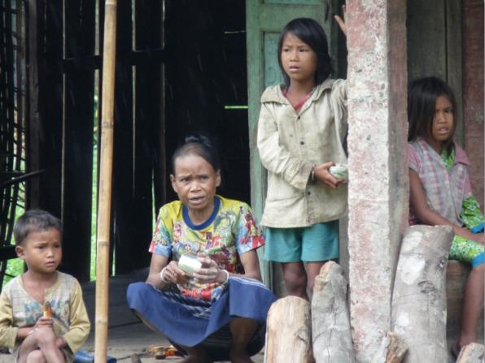

Arem people living inside Phong Nha – Ke Bang National Park World Heritage Site. Over 400 minority people currently live inside the protected area.

- Relevant Laws and Regulations

The International Convention and Operational Guidelines for World Heritage Sites guide the management of all World Heritage Sites.
- International Convention on Cultural and Natural Heritage Protection dated November 16th 1972;
- Operational Guidelines for the Implementation of the World Heritage Convention, UNESCO World Heritage Centre, 2005.

Of particular relevance to the management of PNKB NP WHS are the Law, Decrees and Decisions that regulate management of protected forests (“Special Use Forests”) in general and Phong Nha - Ke Bang National Park in particular:

- Law on Forest Protection and Development, dated December 3rd, 2004;
- Decree No. 23/2006/NĐ-CP on implementation of the Law on Forest Protection and Development;
- Decision No. 186/2006/QĐ-TTg on promulgating the Regulations on Forest management;
- Decree No. 117/2011 of the Government of Vietnam on special-use forest organization and management;
- Circular No: 78/2011/TT-BNNPTNT of the Ministry of Agriculture and Rural Development guiding implementation of Decree 117.
- Decision No.: 24/2012/QD-TTg of the Prime Minister On investment policy for development of special – use forests in 2011 – 2020.
- Decision No. 189/2001/QĐ-TTg of the Prime Minister on upgrading Phong Nha – Ke Bang Nature Reserve to National Park dated December 12th, 2001;
- Decision No. 18/2007 of the Quang Binh Provincial People’s Committee issuing regulations on management of Phong Nha - Ke Bang National Park;
- Decision No. 442 /UBND of the Quang Binh PPC ref. agreement for investment project and opening a specially-used road to Paradise Cave dated March 3, 2010.
- Decision No. 2235/QD-TTg of the Prime Minister on approval of development of a construction master plan for Phong Nha - Ke Bang National Park until 2025;
- Decision No 857/QD-UBND dated 20th April 2007 by the Quang Binh Provincial People’s Committee approving planning 2006-2010 for three forest types
- Decision No 1678/QD-UBND dated 14th July 2008 by the Quang Binh Provincial People’s Committee on land allocation to Phong Nha Ke Bang National Park Management Board

Decision No. 18/2007 sets out the regulations for the various Sub-Zones of PNKB National Park (“the Core Zone”) and the surrounding Buffer Zone (see Annex IX).

In addition to the laws and regulations on forest protection and environmental protection listed above, other relevant national and regional level government laws, decrees and regulations include:
- Law on Organising People’s Council and People’s Committee, dated November 26th, 2003;
- Law on Biodiversity, dated November 13th , 2008;
- Law on Tourism, dated June 14th, 2005;
- Law on Cultural Heritage, dated June 29th , 2001;
- Law on Land, dated November 26th, 2003;
- Law on Investment, dated November 29th, 2005
- Decree 32_30_March_06 on protection of endangered species
- Decree No. 92/2007/NĐ-CP of Government on detailing the implementation of some articles in the Law on Tourism;
- Decision No. 104/2007/QĐ-BNN promulgating regulations on Management of Ecotourism activities in National Parks and Nature Reserves;
- Decree No. 92/2002/NĐ-CP of Government on detailing the implementation of some articles in the Law on Cultural heritage;
- Decree No 181/2004/ND-CP on implementation of the Land Law;
- Decree No. 108/2006/NĐ-CP of Government on detailing the implementation of some articles in the Law on Investment;
- Decree No 34/2000/ND-CP by the Government on Regulations for Border Areas of Socialist, Republic of Vietnam;
- Circular No. 179/2001/TT-BQP by the Ministry of National Defense on implementation guidelines of Decree No 34/2000/ND-CP by the Government on Regulations for Border Areas of Socialist, Republic of Vietnam (SRV);
- Coordination Regulations on management of national territories and border lines in the province of Quang Binh (issued with attached Decision No 59/2006/QD-UBND by Quang Binh PPC)

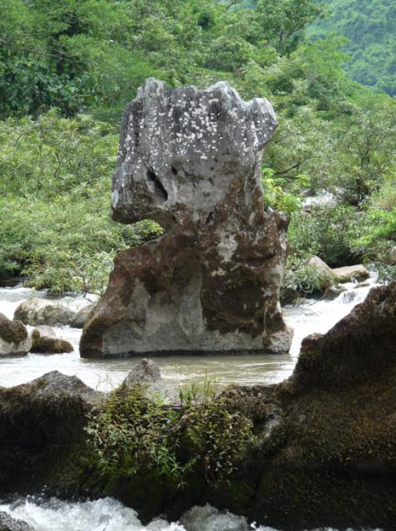
- Environmental Impact Assessment Process

Proposals for infrastructure construction, works, and other development activities within and adjacent to the PNKB NP WHS are assessed using the normal environmental assessment processes applied by Quang Binh Province and Vietnam under relevant legislation.

Article 110 of the Operational Guidelines for the Implementation of the World Heritage Convention make clear that “impact assessments for proposed interventions are essential for all World Heritage properties.”

In Vietnam, any project that uses part or all of the land area of or causes an adverse impact in a world heritage site or national park protected under decision of a Provincial People’s Committees is required to prepare a full Environmental Impact Assessment Report. The Provincial-level environmental protection agency must review, approve and certify the environmental protection schemes and examine and inspect the environmental protection work (Decree No. 80/2006/NĐ-CP and Decree No. 21/2008/ NĐ-CP).

The following legislation is relevant and binding:
- Law on Environmental Protection, dated November 29th, 2005;
- Decree No. 80/2006/NĐ-CP on detailing and guiding the implementation of a number of Articles of the law on environmental protection;
- Decision No. 02/2003/QĐ-BTNMT of Ministry of Natural Resources and Environment promulgating regulations on Environmental protection on the field of tourism;
- Decision No. 22/2006/QĐ-BTNMT of the Ministry of Natural resources and environment on applying Vietnamese standards on the environment;
- Decision No. 104/2007/QĐ-BNN promulgating regulations on Management of Ecotourism activities in National Parks and Nature Reserves;
- Decree No. 59/2007/NĐ-CP on managing solid waste;
- Decree No. 21/2008/ NĐ-CP amending and supplementing a number of articles of the Government’s Decree No. 80/2006/ND-CP, detailing and guiding the implementation of a number of articles of the Law on Environmental Protection.

- Analysis of Threats

The following summaries provide more details on the nature of the threats that are putting pressure on the Park’s outstanding universal values and other values. These are listed in order of priority, based on their seriousness and severity of their impacts. Many constraints and weaknesses of the Park management that hamper its ability to effectively respond to these threats. These are not dealt with here, but are considered in the Strategic planning and resulting actions as detailed in the Operational Management Plan.

Wildlife hunting and trapping: Illegal exploitation of wildlife is the greatest threat to the biological integrity of PNKBNP. The majority of threatened species in PNKBNP are primates and large mammals. In addition, other animal species are also hunted from the Park, including wild pig, civets, porcupines, turtles, and snakes. Hunting is widespread all over the region and all year round. Large and medium-sized animals, including primates, are mainly hunted in the Core Zone of the Park; while only small animals like rats and squirrels can still be found and trapped in the Buffer Zone. The peak hunting season is from August to March. Local hunters (coming from Buffer Zone communes) mainly comprise amateur opportunists who hunt during their spare time as a hobby; a tradition and a way for them to appreciate the forest and its natural specialties. Hunters coming from outside the Buffer Zone (e.g. from Bo Trach, Quang Trach, Tuyen Hoa and Minh Hoa districts of Quang Binh province) are mainly professionals, who are very skillful, know the forest very well, often hunt during the best hunting season and conduct long hunting trips in the forest. Information from consultation meetings and interviews in Thuong Hoa and Hoa Son communes revealed that those professional hunters also often collect other forest products during their hunting trips.

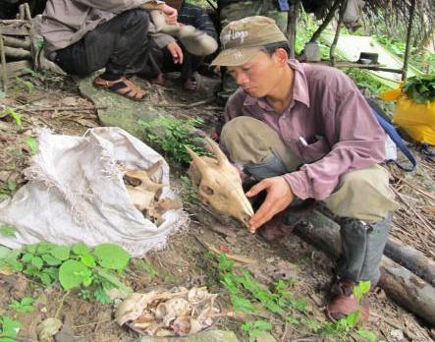

A sack of bones in a hunters’ camp includes the skull of a serow, Capricornis milneedwardsii.
Illegal hunting and timber poaching have been major threats to the biodiversity of
Phong Nha – Ke Bang National Park World Heritage Site. Photo: Le Trong Dat
In the past, hunters and trappers used both guns and wire snare traps to catch mammals, but now mainly traps made of steel cable are used. Sometimes, trained hunting dogs are also used to search and chase certain kinds of hunted animals, such as mammals, pangolins, turtles and cobras. However, for small mammal species like rats, a kind of small bamboo trap (locally called “bay sap”) is used.

Hunting practice is related to a number of root causes, as follows:

- Bushmeat is of high market demand and high commercial value
- There still exist the need and the habit of using bushmeat for food in some areas.
- Hunting is a traditional custom/habit of local communities living near the forests.
- Local households lack jobs and alternative source of income.
- There is a low level of conservation awareness and limited knowledge of laws and regulations on the protection of this wildlife and the National Park.

Hunting activity is a principal threat to the survival of wildlife species in the region, especially for species that feed and move on the ground (e.g. civets and galliform birds). A bird biodiversity survey conducted by BirdLife International in 2011 in the Park’s extension area pointed out that a number of pheasant species, namely Green Peafowl Pavo muticus, Silver Pheasant Lophora nycthemera, Crested Argus Rheinardia ocellata, have been extirpated in the surveyed area. Turtle species also have become very rare.

Illegal logging: Despite major efforts by the Park to curtail it, illegal logging does still happen in the Park, targeting a number of species of high commercial or utility values such as: Dalbergia tonkinensis (Hue/Trac), Diospyros mun (Mun), Vatica spp. (Tau), Erythrophloeum fordii (Lim), Michelia spp. (Gioi), Huynh Tarrietia javanica, Chua Embelia ribes, etc. Timber species of high commercial value were extracted in the Core Zone of the Park, including the newly extended area, whilst timber for domestic use by local communities was mainly extracted in the Buffer Zone forests which are now under the management of forest companies. Hoa Son commune is an exception, where so far no timber extraction was observed in the Core Zone of the extension area of the Park. Logging happens all year round, but is most intensive during low agricultural season (i.e. after the harvest seasons of agricultural products).
Logging is conducted by both local people and people from other districts in Quang Binh Province, and for both domestic use and commercial purposes.

Illegal logging is driven by a number of causes as follows:

- The timber resources in the Buffer Zone forests are considerably depleted and therefore timber in the Core Zone of the Park is now targeted for logging.
- There are not enough jobs and alternative sources of income for local households.
- Many households in Buffer Zone communities do not have enough forest land for their household needs or to develop agro-forestry/plantations.
- Awareness raising among local communities on the conservation importance of the Park and laws and regulations regarding the protection and conservation of the World Heritage Site are still low.

As a result of illegal logging, many big timber species has become extremely rare or have even been locally extirpated due to prolonged overexploitation, such as Dalbergia tonkinensis (Hue) and Aquilaria crassna (Tram huong).

Non-timber forest product exploitation: Non-timber forest products (NTFPs) have been extracted from the Park for many years. These consist of rattan (tribe Calameae), medicinal plants, orchids such as Anoectochilus setaseus (Lankimtuyen), Ardisia silvestris (La khoi/Com nguoi rung), palm leaves, bamboo shoots, bee honey, etc. This activity is carried out by communities inside and outside the Buffer Zone of the Park. NTFPs extraction activities are carried out all year round, except for bamboo shoots and bee honey that have to be collected in the right season. NTPF extraction is widespread and its intensity depends on the availability and richness of NTFPs in each region.

Unsustainable harvesting practices have resulted in the rarity of some NTFPs such as Anoectochilus setaseus orchids and rattan within the Park and Buffer Zone.

Cinnamomum oil extraction is still being carried out in PNKB region, but has declined considerably. This activity is often observed in the Core Zone or Buffer Zone of the Park where forest quality is still good. This activity is carried out by local people from outside the Buffer Zone (e.g. Ron commune of Quang Trach District) with participation of local villagers. Cinnamomum oil extraction not only depletes Cinnamomum species, which are of conservation concern, but also damages the habitats around extraction camps (as trees around those camps were felled to be used as fire-wood) and pollutes nearby streams.

Fishing is a direct threat to the Park’s biodiversity. The Park’s dominant topography is limestone karst, so there are very few above-ground streams and rivers in the Core Zone. Local people still fish in the Buffer Zone, normally using nets, but sometimes using electroshock devices and poison made from tree bark. Harvested fish are used for consumption in families and sold to market. Fishing happens also all year round, except for the two flooding months of September and October. Fishing using electric devices and poisons has widespread destructive impact on fish species and other aquatic life.

One exceptional NTFP appears to be wild honey collected by indigenous people in the Phong Nha - Ke Bang region. This was considered to be a very sustainable collection practice, which could be encouraged so as to be widely shared and replicated.

A number of root causes create incentives for unsustainable collection of NTFPs:
- High market demand
- Subsistence needs of local communities
- For the many local people who lack jobs and alternative income sources, NTFP collection provides a ready source of supplementary household income

Destructive tourism: PNKB NP has very high potential for cave and exploration tourism. The number of national visitors to the Park increased from 115,000 visitors in 2001 to 329,000 visitors in 2004, and the numbers continue to climb. The number of international visitors is also increased from 1,000 in 2001 to 11,800 visitors in 2007, and visitation by international travellers seems to be increasing even more quickly.

Mass tourism with low environmental awareness may cause disturbance to both local human communities and wildlife. There is already heavy pressure on certain popular touristic sites, resulting in noise and litter. Some villagers in Phuc Trach commune (near Paradise Cave) observed that tourism activities cause noise that disturbs non-human primates, air pollution and water pollution. Currently there very few sign posts, information boards with conservation guidance and messages and garbage bins in popular tourist locations in the Park, such as Phong Nha Cave, Paradise Cave, and popular streams.

Caves are particularly fragile environments, and tourism to these sites can leave permanent damage if not carefully planned and supervised. Tourism facilities installed inside the caves and the over-crowded tourist masses during summer months also cause negative impacts on the cave features and rare cave wildlife. Lighting systems can allow the growth of algae (lamp flora), which can discolour and permanently damage cave features.

To date, there has been no study on the impacts of tourism on the conservation of the Park or its World Heritage values. As tourism is developed and expanded, with plans to allow increase of tourism numbers and spread tourism to other parts of the park, there are bound to be further threats both to the tourist experience itself as well as to geomorphology and endemic biodiversity of the World Heritage site.

Infrastructure developments inside the Park: The West branch of Ho Chi Minh Highway is a national project serving economic development and national defence purposes. The road lies along the boundary of much of the Park, and crosses through the Park’s Ecological Restoration Area. The construction of the road caused some disturbance to the Park.

Road 20 crosses directly through the park from north to south. This road was constructed before 1965 and goes through PNKBNP. This is the only road for Thuong Hoa and Tan Trach communes to access Phong Nha. Currently, Road 20 is being upgraded. From an economic development perspective, upgrading the road will help Tan Trach and Thuong Trach communes access the outside world and market. It will also make the Park more accessible, therefore the Park’s guard station at 39th Km and the check-point at 27th Km shall need to step up their enforcement and patrols. Attention should also be paid to raising the conservation awareness of local communities in Thuong Trach and Tan Trach communes.

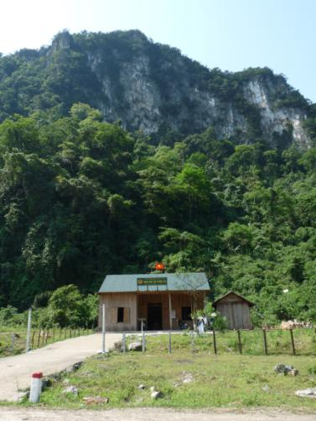
Invasive alien species:
Forest Protection Station on the edge of Phong Nha – Ke Bang National Park. Forest and wildlife protection is major
functions of the Park’s management.
Invasive alien species in the Park are mainly comprised of herbaceous and lianoid plants, such as Co lao (Chromolaena odorata), Trinh Nu moc (Mimosa diplotricha), Thom oi (Lantana camara), Co tranh (Imperata cylindrica). The issue of invasive alien species has not been considered in the management of the Park previous to this.

Some alien species have been introduced to the region in the process of infrastructure construction (road and other infrastructure works). Some weeds and vine species were observed to be invasive, slowing down the natural rehabilitation/re-growth of forest adjacent to the Buffer Zone and along new roads.

Firewood collection: Extraction-Firewood collection in the Park is a common practice among local communities in the Buffer Zone.
Sometimes, firewood collected is also sold to “middle-men” for sale to further localities in the region. Firewood is an important source of fuel for households, due to their increasing fuel/firewood demand and the declining area of forest available to meet that demand. Currently, there is not yet any study on the firewood demand of local communities as well as the impacts of firewood collection on biodiversity in the region. Some projects have piloted distributing fuel-saving stoves that use firewood replacement materials such as sawdust and rice husks, but those stoves are not popular, as the collection and use of firewood is much easier, faster and more convenient for local communities. In the longer term, without alternatives, this firewood collection practice will negatively impact the quality of natural forests.

Cattle grazing in the Park: Cattles grazing in the forest is a traditional practice of Buffer Zone communities. For example, 100 oxen belonging to households in Tan Trach commune graze in the Core Zone of the Park.
Main causes of the situation are:
- Allowing cattle to graze freely in the forests is a traditional practice in local communities.
- The need for pasture was not taken into account in land-use planning in the buffer zone communes.
Uncontrolled cattle grazing as it occurs today may negatively impact the enrichment planting of native species in the area targeted for this activity.

Forest land encroachment: According to information obtained from the consultation meetings with villagers and local authority in Arem village, Tan Trach commune, 70 households of Tan Trach commune are living inside the Core Zone, with about 150-200 ha of agricultural land. In addition, inside the Core Zone there is also 1 ha of agricultural land, used for growing maize and peanuts, which belongs to people from Chay Trai village, Phuc Trach commune.
Causes of encroachment are:
- Park planning did not adequately consider the land-use demand of Tan Trach commune;
- Subsistence needs of a growing population;
- Lack of agricultural land for buffer zone communities outside of the Core Zone;
- Low level of conservation awareness and awareness on forest protection laws and regulations.

Forest fire, floods, natural disasters and Climate Change: Forest fire seldom happens in Phong Nha – Ke Bang region. However, sometimes there are small fires in forest near agricultural land. There does exist the risk of forest fire due to slash and burn practice, infrastructure developments, wild bee honey collection and negligence by tourists and other visitors. Anthropogenic climate change, bringing with it erratic and unpredictable shifts in weather patterns, may increase the risk of severe drought and major fires in the future.

Every year, the PNKB region suffers from floods for 2-3 weeks during September and October. This natural seasonal flooding interrupts tourism activities each year. Occasional severe floods cause negative impacts on wildlife and habitats and have obvious destructive impacts on tourism infrastructure.

The frequency and severity of forest fires, floods, windstorms and other natural disasters may be intensified by change due to anthropogenic climate change (“global warming”).
- Regulations for Sub-Zones of the National Park

Article 7 and 8 of Decision No. 18/2007/Decision of the Quang Binh Provincial People’s Committee sets out the following proscriptions for the various Sub-Zones of the National Park (“the Core Zone”) and the surrounding Buffer Zone.

Natural resources, historical and cultural relics, and landscapes in the functional zones of Phong Nha - Ke Bang National Park have to be protected intact and sustainably developed.

1. In the Strictly Protected Area and Ecological Restoration Area of the Park, the following activities are banned:
- Activities that can change natural habitat of the forest except activities has been done according to the regulation on forest management, mentioned in Point 2b, Article 22, attachment with Decision No.186/2006/TTg of Prime Minister on 14th August 2006.
- Activities that can impact to environment, natural habitat of fauna and flora or species that are being conserved.
- Keeping and raising animals or growing animals/plants which are not native species located in Quang Binh province. In the special cases, they need to be decided / approved by the Minister of Agriculture and Rural Development or Primer Minister.
- Exploit biological, mineral resources and others; change natural habitat and forest accession; negative impact to wildlife/wilderness.
- Domestic cattle and fowl husbandry
- Make environment polluted such as solid garbage, daily garbage and other activities
- Bringing poison chemical, explosive, inflammable into forests, fire on forests and edge of forests or use means of transport are threatened to natural environment.
- Activities make damage, destroy, illegal occupy historical, cultural relics and landscapes; writing or painting on the caves, trees, historical sites and natural landscapes.
- Building houses, stores, pagodas, tempers, stations, mine exploitation or tourism facilities; except activities mentioned according to the regulation on forest management, Point 2b, Article 22, attachment with Decision No.186/2006/TTg of Prime Minister on 14th August 2006.
- Superstition acts, putting up statues and altars on the caves, mountains, rivers and impolite behaviors at the tourism sites or on the vehicles.
- Establish repair bases, shops/restaurants, photo shops or other services are not permitted by the authority.
- Use land and forest have been planned that belong to Strictly Protected Sub-zone for rent or cooperation which can change natural evolution of the forests.

2. In the Administration Area, the activities mentioned below are banned
- Activities that can change natural habitat of the forest, activities can impact to environment, natural habitat of fauna and flora.
- Keeping and raising animals or growing flora which are not native species located in Quang Binh province. In the special cases, the need to be decided by Minister of Agriculture and Rural Development.
- Exploiting endangered, rare floral species are banned (except dead or collapsed wood-trees and trees located in ground for construction sites according to the planning) based on Decree No. 32/2006/ND-CP of Government on endangered, rare forest fauna and flora management and category of both endangered, rare forest fauna and flora has been issued attachment.
- Illegal hunting, trapping wildlife and other exploitation activities involved in biological resources that to be banned by law provisions
- Natural resources exploitation such as stone, stalactites, war-weapons and other resources.
- Making environment polluted
- Bringing poison chemical, explosive, inflammable into forests, fire on forests and edge of forests or use means that threatened to damage natural environment.
- Activities make damage, destroy, illegal occupy historical, cultural relics and landscapes; writing or painting on the caves, trees, historical sites and natural landscapes.
- Building new facilities change or destroy the buildings that they have been negative impacted to forest ecology, growth and development of biological organism when not yet approved by authority.
- Superstition acts

3. In the Buffer Zone, the following apply:
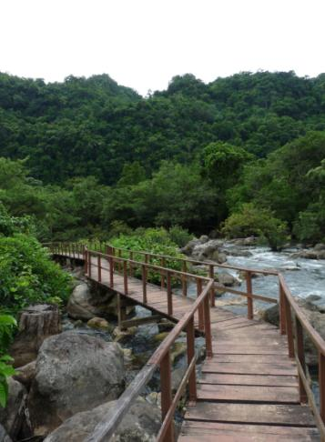
- Buffer Zone is bordering with natural forest and slope in the side of Phong Nha - Ke Bang National Park. It needs protect in accordance with law on forest protection and development. In the bare land and hills, it needs plan for native species forestation and building sustainable forest garden.
- The Management Board of Phong Nha - Ke Bang National Park organizes activities for local community in Buffer Zone can participate in protection, conservation, forest product use and other natural resources, eco-tourism services in order to improve income and livelihood of community.
- Master plan is needed for local residence. All organization and individual buildings have to be approved by functional authority such asarchitectures, designs, border marks and permit for construction. It is sure that not make polluted and negative impacts to natural landscapes of Phong Nha - Ke Bang National Park.
On the Ngoc Mooc Ecotrail inside Phong Nha – Ke Bang National Park World Heritage Site.

- Services of hotels, guesthouses, shops, restaurants, ships, boats, and sport and entertainment complexes have to provide solutions for waste, garbage; prevent direct or indirect pollution to landscapes and natural environment.
- If the proposals of building industrial, economic zones and construction sites can be risked affect to protected area of Phong Nha - Ke Bang National Park. It is necessary to carefully consider and find solutions to minimize negative impacts and handle.
- The Management Board of Phong Nha - Ke Bang National Park is responsible for coordinating with local authority, relevant departments and agencies to implement measures of management and protection according to the government regulations on historical and cultural relics, landscapes protection.
- Wildlife and wilderness as well as other resources of Phong Nha - Ke Bang National Park are banned trading.

Article 15 of the same Decision deals with settlements of local community in the functional zones of the National Park.
- It is not allowed to immigrate into Phong Nha - Ke Bang National Park
- The Management Board of Phong Nha - Ke Bang National Park assists the Provincial People’s Committee in building plans for resettlement to submit to state authority for approval. This programme is to remove people who are located in the Strictly Protected Area of National Park from this area.
- If people who live in the Strictly Protected Area but not yet removed, local individuals and households can be allocated forest in short term for protection by the Management Board of Phong Nha - Ke Bang National.
- In the Ecological Restoration Area, the Management Board of Phong Nha - Ke Bang National can directly allocate forests to local individuals and households for protection and development.

Tourism activities in PNKB NP are regulated under Decision No 104/2007/QĐ/BNN of the Ministry of Agriculture and Rural Development regarding the regulations on eco-tourism activities and management in national parks and reserves.

Both, Decision No 104/2007/QĐ/BNN and the draft ‘Regulatory framework for management of tourism activities in Phong Nha - Ke Bang National Park’ address the management of tourism activities inside the National Park.

Decision No 104/2007/QĐ/BNN allows the PNKB NP to be land managers, but also to be tourism operators in the protected area environment. The tourism concession system could also be easily integrated with ‘Regulatory framework for management of tourism activities in Phong Nha - Ke Bang National Park’ and it would also align to the regulatory principles of Decision No 104/2007/QĐ/BNN.

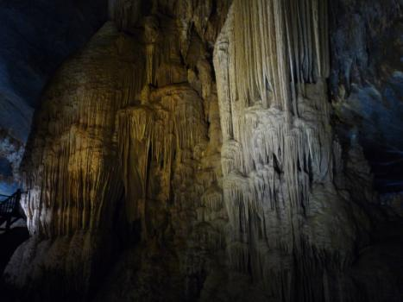

Speleothem inside the developed part of Paradise Cave.
- Guidelines for a Visitor Management Plan for PNKB NP WHS

(Adapted from Eagles, P. et al., (2001) Guidelines for Tourism in Parks and Protected Areas of East Asia.)

A visitor management plan for PNKB NP WHS has been specifically requested by the UNESCO World Heritage Committee. The plan should be part of the Operational Management Plan, updated every five years. The process for development of the Visitor Management Plan involves 15 steps, with a review and revisions every five years:

- Step 1: State clearly the objectives for visitor management in the National Park.
- Step 2: Compile an inventory of natural and cultural features, as well as of existing visitor use and potential. Map and analyse the information.
- Step 3: Involve local people and local government in the planning. This is key.
- Step 4: Work in partnership with local government, tourism businesses and other regional and local organisations.
- Step 5: Map and demarcate Sub-sub-zones within the Sub-Zones of the National Park in areas where tourism impacts will not harm resources of ecological significance, including High Volume Tourism, Nature and Culture Tourism, Community Benefit Tourism and Strict Ecotourism Sub-areas and Tourism Infrastructure Sub-area.
- Step 6: Develop limits of acceptable use for all sub-zones and sub-sub-zones of the National Park. Set environmental standards and design mechanisms, including monitoring, to ensure that they are met.
- Step 7: Determine which tourism activities are compatible with the National Park’s objectives and which are not. Develop related policies and regulations for the sub-sub-zones.
- Step 8: Assess the environmental, economic, social and cultural impacts of proposals for tourism development from businesses and local government.
- Step 9: Develop education and interpretation programs for visitors and local people that increase understanding and appreciation of the area’s environment, culture, heritage and other important issues.
- Step 10: Design methods to ‘channel’ (meaning ‘to direct’ or ‘to guide’) visitors through desired areas and away from fragile areas, so that there are minimal negative impacts.
- Step 11: Survey and analyse tourist markets and visitors’ needs and expectations.
- Step 12: Brainstorm potential tourism products to be developed so as to influence the types of visitors choosing to visit. Identify the values and image of the National Park on which to base sustainable tourism and outline a promotional strategy for the protected area. (Note: This step applies if the National Park’s objectives include promotion of tourism. If the objective of the tourism management plan is simply to control tourism to ensure sustainability, then it is not needed.)
- Step 13: Plan a program for monitoring use by visitors and their impact on the national park. At appropriate intervals, evaluate the success of the plan in ensuring that tourism use maintains environmental standards and revise the Tourism Plan as needed.
- Step 14: Assess resource needs and potential sources, including provisions for training, recruiting staff, procuring equipment and budget.
- Step 15: Implement the plan.

- Cave Management and Cave Management Prescriptions

PNKB will use cave management prescriptions and Cave Management Plans to regulate development of tourism to caves so as to protect the Outstanding Universal Values of PNKB’s caves and karst World Heritage.

Cave management prescriptions are composed of a number of requirements that place restrictions on activities undertaken in caves and on the karst around them. The prescription for each cave is designed specifically for that cave, and thus may differ due to the differences between individual caves. The focus throughout is on conservation, with three general factors considered in each case:
  - The long term conservation needs of the cave and its speleothems and other heritage features;
  - The long term conservation needs of the cave flora and fauna;
  - The safety of visitors.

Achieving these three general factors is the overall goal, and cave management prescriptions can be developed by examining the specific features of each cave that contribute to these three general factors. Specific sub-factors need to be considered when determining that a cave or section of a cave should have a cave management prescription. These sub-factors include:
- Is the number of visitors to the cave high?
- Is the cave threatened by deliberate vandalism or collectors?
- Does cave contains delicate areas of speleothems?
- Does the cave contain flora or fauna that require protection?
- Is the cave the subject of significant research activities?
- Is the cave impacted by above ground or upstream land uses?
- Is the cave known to have high levels of CO²?
- Is visitor safety in the cave threatened by flashflood or rockfall?

In electing which caves should have management prescriptions, the specific sub-factors outlined above are reviewed for each cave, and those caves that one or more of these sub factors pertaining would be given priority for management prescriptions. If none of these sub-factors apply, then when experienced cavers and researchers apply to visit a cave, they would be encouraged to collect information about the cave during the visit. If a cave has little or no documentation, then managers should ask the cavers to provide a written report highlighting the features of the cave that they observe. If the visitors have any specific skills relating to the caves, such as the ability to map or to identify cave fauna, etc., then this additional information should be added to the report.

In this manner, features of caves that may otherwise be missed will eventually be identified. This may result in the application a new management prescription to the cave. For example, a management prescription may be applied to conserve newly identified cave species in one section of a cave.

In order to devise the actual cave management plan that details the prescription, the areas of concern are listed for each cave and then methods for minimizing caver impacts and/or ensuring safety are written into the prescription. If it is considered that cavers are such a threat to a specific cave or area of cave then they should be excluded. If the cave or section of cave is considered such a threat to visitor safety that it should be visited then that cave or section can be prescribed as closed. These are two extreme examples, with the majority of cave management prescriptions providing access to caves with only some restrictions applying.

The Cave Management Plan should have the following sections:
- Applicable Sub-factors: A checklist of the answers to the questions above,
- Issues: Details of the exact nature of the sub-factors that apply for this cave.
- Proposed Management Interventions: Listed by Sub-factor
- Proposed Restrictions

The Cave Management Plan should provide a concise summary of the management prescriptions, focusing on the sub-factors that may endanger the cave’s heritage value or the safety of visitors. The Management Plan should always ensure that the three general factors are its overriding goal, taking all of the sub factors into consideration.

A Cave Management Plan, like any management plan, should not be considered as a final unchanging prescription. The cave management Plan should be an evolving document that changes as additional information or additional needs come to light. It should be modified on a regular basis as new information is obtained about the cave or as the sub factors are adjusted, always with the three general factors as the overriding goal.

Management prescriptions can be applied to other sites of heritage value in the World Heritage Site, such as dolines, springs or historical sites.

The Phong Nha - Ke Bang Management Plan has determined that a cave management plan should be developed for the Phong Nha Cave, Paradise Cave, Dark Cave, En Cave and all other existing tourist caves of the Park as a basis for protecting and professionally presenting the World Heritage OUV.

- The cave management plan should have regard to the management guidelines for show caves developed by the International Speleological Society. Cave formations are mostly a non-renewable resource and need to be protected.

- The cave management plan needs to include an environmental impact assessment process for any non-maintenance management intervention or change that may impact the World Heritage OUV (See section 4.11)

- For infrastructure to be placed within the cave, regard shall be had for minimising impacts. Crowd control infrastructure and within cave access facilities (such as fences, steps and elevated walkways) should not impact speleothems or other natural phenomena such as cave ecosystems. Cave lighting placement and use should be undertaken carefully and lampenflora removed and controlled. Cave lighting needs to be respectful of the natural phenomena (use of white light) and the placement of electricity cables needs to be very sensitively achieved. The placement of backlit sign-posting including World Heritage presentation information and emergency evacuation lighting needs to be carefully achieved.

- Any infrastructure present or installed in the cave should be professionally designed, of high quality and worthy of World Heritage presentation status. The materials used and the construction techniques applied need to be suitable for a cave environment. Wood or other organic material, for example, is not recommended by the International Union of Speleology and welding (with its associated waste-gas generation) would be a major impact to the cave.

- For World Heritage Presentation, the World Heritage status and OUV of Phong Nha-Ke Bang National Park and the particular cave is professionally presented for all visitors including through verbal presentations by guides, through signs and through printed information. Ideally, the World Heritage OUV presentation information would be designed to suit the unique characteristics for each cave, guides would be professionally trained and the cave presentation information provided in more than one language. The OUV information could be presented simply as well as technically (for more discerning visitors).

- The World Heritage cave experience for visitors is very important. It should be high quality and safe. This should usually include: 1) Pre-cave inspection literature, a safety briefing, a briefing about speleothem protection and the World Heritage status (and what this means) for individuals and groups; 2) Pre-departure logistic advice about how the group is to be managed, pre-visit comfort stops and advice about a non-smoking policy and the reasons for this; 3) Crowd control and strictly controlled group size and frequency of group use for all parts of the visit that is consistent with visitor use prescriptions provided by the cave management plan; 4) Quiet enjoyment of the visit and noise minimisation on the visit; and 5) The provision of a diversity of group experiences, from full technical karst explanations to lay-language presentations

- Impacts to the tourist cave’s World Heritage OUV need to be minimised. The effective management of people is a key to achieving this. This includes:
- For groups: Designing a maximum group size, including an accompanying guide
- Visitor ticketing and group management systems to, from, and within the cave that are organised so that groups receive an optimum World Heritage cave experience that minimises group interaction including orchestrated movements of groups that prevent chances of crowding
- Financial return that is based on $ yield rather than visitor volume and with return visitation targeted thanks to the provision of quality visitor experiences.
- Group control and surveillance by guides to ensure visitors stay on the official pathways, don’t touch or damage formations, do not steal speleothems nor leave any waste in the cave
- Management of groups to minimise noise
- Management of visitors to the cave (non-tourists such as electrical maintenance contractors) to minimise any potential impacts to the cave formations, cave atmosphere, cave hydrology or cave ecosystems through thorough pre-work briefings and within-cave operational guidelines
- Management of within cave official functions to be respectful of the World Heritage status and to ensure they do not impact the cave in any way, especially the cave atmosphere from pollution (fireworks and the burning of hydrocarbons within the cave for example should never happen)
- No solid or liquid pollution of the cave
- Removal of all waste from the cave, undertake restoration work and, if appropriate, cave cleaning work.

- UNESCO Man and the Biosphere Program, Biosphere Reserves

There is currently an opportunity in the PNKB Region to capitalize on the support provided by foreign donors for planning and activities in the Buffer Zone of the Park by establishing an appropriate and institutionalized mechanism to encourage cooperation and appropriate management of adjoining lands. These lands could be managed not only to be compatible with protection of the Core Zone of the Park, but also to manage the Buffer Zone so as to add value to the Park and improve its ecological security and promote appropriate sustainable approaches to development in the Buffer Zone. This might be best achieved by adopting the Biosphere Reserve concept, to which adjacent land managers could subscribe.

In fact, over 30 World Heritage Natural Sites are also associated with UNESCO Biosphere Reserves, for example Uluru-Kata Tjuta National Park WHS and the Tasmanian Wilderness WHS in Australia, Serengetti National Park WHS in Tanzania, Mammoth Cave National Park WHS in the United States, and the Maolan National Nature Reserve site of the South China Karst Cluster WHS.

A Biosphere Reserve is a specific concept that includes one or more protected areas, such as a National Park, and surrounding lands that are managed as a unit, with coordinated management in designated Core, Buffer and Transition Zones to combine both conservation and sustainable use of natural resources. The Core Zone for a proposed Biosphere Reserve would be the PNKB NP WHS itself.

The main characteristics of biosphere reserves are:
- Achieving the three interconnected functions: conservation, development and logistic support;
- Outpacing traditional confined conservation zones, through appropriate zoning schemes combining core protected areas with zones where sustainable development is fostered by local dwellers and enterprises with often highly innovative and participative governance systems;
- Focusing on a multi-stakeholder approach with particular emphasis on the involvement of local communities in management;
- Fostering dialogue for conflict resolution of natural resource use;
- Integrating cultural and biological diversity, especially the role of traditional knowledge in ecosystem management;
- Demonstrating sound sustainable development practices and policies based on research and monitoring;
- Acting as sites of excellence for education and training;
- Participating in the World Network of Biosphere Reserves.

Vietnam currently has eight sites listed as UNESCO Biosphere Reserves.

- Considerations for review of all tourism plans

All tourism plans and any related EIAs, SEIAs, concession agreements and leasing arrangements for tourism in PNKB National Park will be reviewed carefully by the PNKB NP Management Board, paying particularly close attention to the following considerations:

  - The World Heritage values and other natural and cultural features with tourism development potential are not exploited solely for economic purposes in a way that damages or detracts from their value.

  - Sustainable and efficient management of tourism in the PNKB Region is effectively integrated into tourism planning at the provincial, regional, national and appropriate global levels.

  - Tourism plans and activities are linked and integrated to other conservation and socio-economic development plans and activities in order to achieve maximum efficiencies, while avoiding needless duplication and preventable gaps in the implementation.

  - Tourism planning in the PNKB Region involves stakeholder consultation and supports efforts for collaborative planning to ensure that the interests and ideas of all relevant and affected parties are heard from and incorporated as effectively as possible into tourism planning, development and management. The Park Management Board itself will organize and facilitate processes and procedures for consultative planning and cooperative management.

  - Tourism development fosters community participation and provides benefits to the communities in the Buffer Zone of the PNKB NP Region.

  - Tourism development minimises infrastructure needs and infrastructure development in the PNKB NP and consolidates the infrastructure in the Buffer Zone of the PNKB NP Region.

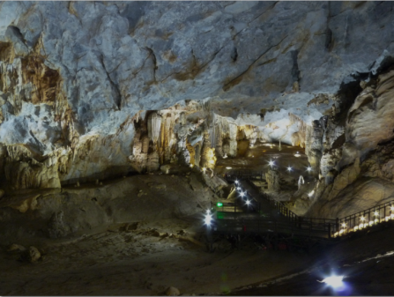

The entrance stairway to the world famous Paradise Cave in Phong Nha Ke Bang
National Park. The Park is expected to receive over 450,000 visitors per year by 2015.
- Forest Conservation and Investment Contracts

Article 8 of the Prime Ministers Decision 24 issues in June 2012 provides support to the management boards of special use forest for investment in community development, to be disbursed on a village by village basis in the buffer zone surrounding the special use forest. Under the programme, the State’s budget shall provide village communities in buffer zones with investment support, at a level of up to 40 million VND per village each year. These investment funding is to be linked to the community’s performance in conservation of forest and biodiversity.
This funding shall be disbursed for items such as;
investment in production development capacity improvements:
- agriculture and forestry extension,
- seedlings,
- breeds,
- small size agriculture and forestry product processing equipment.
supporting the village with construction materials for public construction for the village, such as:
- fresh water supply,
- electric lighting system,
- communication,
- village transportation road,
- cultural hall

This list is not exclusive, but the items on the list can be considered in some sense “pre-approved” by higher authorities.

Planning is to be fully participatory. Detailed budget estimate for annual buffer zone investment shall be developed by village communities themselves. In other words, the village communities will choose their own projects, based on local conditions and needs. The Management Board of special - use forest shall take the lead, in collaboration with Communal People’s Committee, in discussing the projects with each village community for co – approval. (Note that the Management Board does not take the lead in investment project development itself. That is for the village to do, with guidance and facilitation by the National Park.)

Finally, continuation of these community investments shall be directly linked to the special - use forest protection plan and commitment of the village.

Phong Nha – Ke Bang National Park World Heritage Site is in a position to prepare for the roll-out of Decision 24 community investments, thanks to the support of the Nature Conservation and Sustainable Management of Natural Resources in the Phong Nha - Ke Bang National Park Region Project. The experience gained in developing and testing guidelines for implementation will insure rapid and sustainable implementation once full funding is released by the government.

The draft Five Step Process Framework below sketches out an approach to setting up the investment plans and linking them to forest protection performance. This is based the on experience from Pu Luong Nature Reserve (another karst limestone special use forest site in Vietnam), which piloted this Framework as part of a World Bank GEF project.
The Five Step Process

Step 1: Threat Analysis
Since this programme is ultimately implemented in the service of conservation of the Park’s outstanding heritage values, it is important to carry out a threat analysis to focus the programme where it will do the most good. Threat analysis has been carried out in some detail, through the Rapid Threat Assessment done by the GIZ component and the Conservation Needs Assessment carried out by the Management Planning Team. The essential points are summarized in the Strategic and Operational Management Plans for PNKB NP.

Step 2: Criteria and Village Selection
Although Decision 24 would seem to apply to all villages in the Buffer Zone, in fact the National Park has limited staff capacity and funds may be limited. It is therefore necessary to prioritize the villages in the Buffer Zone so as to choose those that are the greatest threat to the Park’s heritage values for early interventions.

Key criteria for selection of villages might include:
- the level of dependence on natural resource extraction for the Park or from other high conservation value forest
- the level of impact that the Park’s restrictions on land use, hunting, logging and NTFP collection have had on the village.
- Whether the village is inside, adjacent or near the Park.

In terms of scope, it is suggested that 16 villages in 8 communes could be targeted initially, reaching about 8 villages each year over the next two years.

Step 3: Resource Assessment and Village Appraisal
Once a village has been selected for the program, additional field survey work is necessary in order to understand the needs of the village, the status of its natural resources and the capacity of the villagers, and to set the stage for Participatory Planning in the village. A number of standard PRA and RRA and Participatory Planning tools can be used for this purpose, such as:
- Village data collection from village leaders;
- Participatory mapping to define patterns of forest use and boundaries;
- A transect walk with the villagers through the different land use areas in the village, to understand development options;
- A critical needs analysis, to understand the forest products needed for subsistence;
- A threat analysis, to gain a detailed understanding of the key threats to conservation at the village level;
- A problem analysis, to gain an understanding of the main development issues in the village;
- A feasibility matrix, to understand development activities that can solve these issues, and their feasibility, including their impacts on conservation;
- A forest and NTFP inventory, concentrating on these species under threat or required for critical needs.

If the inventory shows that sustainable use of NTFPs is possible, then a Forest Protection and Utilization Contract can be considered. The contract should be negotiated jointly and provide details such as the responsibilities, tasks, products involved, and technical prescriptions for a defined area of forest.

If sustainable utilization of NTFPs is not possible, then a standard Forest Protection Contract should be drafted with the community.
Step Four: Drafting Contract Negotiation
The outcome of the appraisal above should be a draft Forest Conservation and Community Investment Contract (FCCIC), developed by the village with the help of the National Park staff and consulting team. This should detail the conservation and development objectives for the village and its forest resources, the management activities, the investment required (up to 4o million VD, and the roles and responsibilities of everyone involved in the partnership.

The draft proposal will be discussed at commune and district level, involving the National Park and the Project (during the Project’s life). The finalized FCCIC should be approved by the Commune People’s Committee and the National Park. For the first pilot FCCIC, it would also be appropriate to obtain approval from the District PPC and from DARD. Future FCCIC’s may only require approval by at the Commune level.

Step Five: Annual Village Action Plans
The BCDC will provide the framework for more detailed annual village action plans, describing management actions, who does what, when, with performance indicators (financial, physical and social milestones) for monitoring progress.
Once co-approved by the National Park and the Commune, funds can be released directly to the village. According to Article 8 of Decision 24, the Management Board shall be assigned to manage the funding in accordance with existing regulations on management of public economics benefit funding.

Performance monitoring will be carried out by the village itself. Conservation monitoring is also necessary to measure the impacts of the programme. Monitoring will be fully participatory and involve elements that the villagers implement (based on simple records of harvesting, benefit distribution, financial data and decisions made). According to Article 8 of Decision 24, the village community shall arrange its monitoring of such activity in accordance with legal regulations on grassroots democracy.

The National Park may independently carry out monitoring of forest condition and other conservation related indicators. This is critical, since according to Article 8 of Decision 24, in cases where the village shows poor performance in its conservation tasks, the National Park Management Board has the authority to shift the funding to another village.

- Training Plan Summary

Training staff of the National Park should provide them with the skills and competencies needed to support the activities in the Management Plan.

These include standard skills sets needed for adequate staff performance in any forest protected area, and include:
- Law enforcement (including training on dealing with violations);
- Communication skills and awareness raising techniques needed to target harvesters, consumers and middlemen with appropriate messages to promote behaviour change.
- Approaches for working with local people, including awareness building, extension services to promote sustainable harvesting forest products, fire-prevention.
- Visitor management and especially for management of caves;
- Communication skills and interpretation and awareness raising techniques for targeting visitors, and training for cave guides;
- Training for cave guards (PNKB NP shall set up a Cave Protection Unit with specific responsibility for controlling visitors to the Park’s caves, with the authority to supervise all activities of any concessions to operate within caves inside the WHS, and these staff will receive special training specifically relevant to cave conservation and safety);
- Senior management training in management planning, public use planning, integrating management with broader landscape management, sustainable development priorities
- Business Planning based on the UNESCO-sponsored training Business Planning for Natural World Heritage Sites – A Toolkit.
- Financial management and procurement, particularly on the specifics of various complex and unfamiliar donor requirements.
- Applied research and monitoring, especially as needed in order to begin monitoring caves, invasive species, and climate change.

In addition to these standard skills sets, several special skills are needed for managing Natural World Heritage sites:
- Understanding the World Heritage Convention and central World Heritage concepts such as Outstanding Universal Values;
- Interpreting and presenting the World Heritage site including communication and outreach;
- Understanding the logistical and organizational aspects of management and World Heritage reporting systems;
- Using monitoring systems that can track World Heritage values and site integrity;
- Managing the large pressure of tourism that World Heritage sites attract;
- Coping with climate change: Managers need to develop skills to understand the likely impacts of climate change as well as the potential of World Heritage sites to combat it.

- Design of Monitoring Protocols

Detailed monitoring protocols will be developed to ensure the quality and credibility of the monitoring. This should ensure that monitoring is carried out consistently, data are suitable for comparative analysis, and any changes detected are real and not due to differences in sampling, for example if staff change. Monitoring protocols will be tested and provision for review built into the protocol.

Protocols should cover:
• Method: Approach or methods used (e.g. sampling, interviews, observation, line transect
techniques, traps or strip census methodology).
• Procedures: Standardized procedures for collecting data, including area of monitoring,
staffing requirements (e.g. numbers, required training, time allocated), equipment requirements
(e.g. vehicles, binoculars, GIS, traps) and safety procedures.
• Frequency of data collection: Monthly, quarterly, annually, etc.
• Data collection: Indicators to be measured (e.g. species, number of sightings, fire
frequency, average earnings of local communities).
• Data analysis: Advice regarding analysis and comparison (e.g. use of graphs, analysis software,
comparisons, etc.)
• Data management: Records will include the monitoring results (data sets) and the history of monitoring development and revision.
Protocol adaptation
• Review: Monitoring activities will be regularly reviewed to ensure that not only are the right things being monitored, but that monitoring is carried out in the most effective way (resources are not being wasted on monitoring unnecessary things), and that the results are used to improve management.
• Revision: Although the aim will be to ensure standardization of monitoring, revision may need to take place due to changes in technology, gaps in data need, budget changes, and changing conditions on the ground, including new pressures and new management approaches.

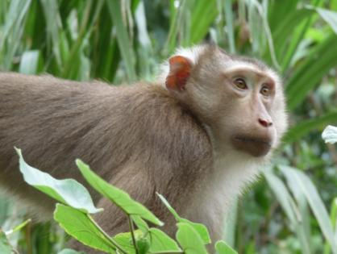
A Northern Pig-tailed Macaque Macaca leonina in Phong Nha – Ke Bang National
Park World Heritage Site. The Park hosts nine species of primates and is an
important area for primate conservation. Photo: WVBleisch/CERS
- Monitoring Plan Summary

To track the effectiveness of management actions is critical in that it provides the information needed to track management success and adapt management as needed. Monitoring will rely both on subjective self-assessments, using various prepared tool-kits, and on field based monitoring of indicators.

- Monitoring management effectiveness: Park staff will repeat the METT assessment carried out in 2008 and 2012, using the same tool used in the past in order to insure comparability and allow assessment of progress. In addition, the Park will begin using the Enhancing our Heritage Toolkit, which uses the IUCN World Commission on Protected Areas framework to develop a range of more detailed assessment tools for managers of natural World Heritage sites. The toolkit will be used to develop comprehensive site-based systems for assessing management effectiveness.
- Monitoring threat reduction: Park staff will carry out a participatory Threat Reduction Assessment, comparing with the baseline Assessment carried out in 2012 using the same protocols to improve comparability.
- Monitoring tourism: The World Heritage nomination process requires tourism to be assessed (see section 5 of the nomination format); including visitor numbers and trends, and visitor facilities and services, such as interpretation / explanation, infrastructure, accommodation and rescue operations. The UNESCO Periodic Reporting format requires information on these aspects and includes rating of tourist facilities and capacity to manage tourism.
- Monitoring impacts of Management Action on reducing hunting: Monitoring of Hatinh Langur and Douc Langur according to transects. Repeat surveys according to fixed treks (applied for monitoring in 2000-2003). Survey of gibbon great calls: Listen for morning great calls in the early morning (4.30a.m - 5.00a.m in summer, 6.00a.m - 7.00a.m in winter). Training for responsible staff. Sampling in a fixed area at the same time (refer to report in 2007). Camera trap (Hatinh Langur) Put camera traps in sleeping caves. Count numbers of traps and snares in a fixed plot and on patrol. Sightings of hoofed animals (gaur, deer, muntjac) during patrols expressed as number/km (Index of Kilometric Abundance, IKA). The MIST management information system used in Uganda and Cambodiawill be introduced as a tool to integrate data collected by patrollers and produce information useful for Park managers.
- Monitoring impacts of Management Action on reducing illegal logging: Repeated forest resource inventory in fixed plots and through satellite image interpretation. Patrol staff will also count freshly cut Stumps on patrol. Research staff will track survival of known high-value trees in a fixed area, registering and securing all data to prevent theft.
- Collection of NTFPs: Survey on amount of high value species of NTFPs in priority areas in fixed plots. Interview harvesters (focal group surveys) to track change in harvest per effort.
- Fire wood use: Inventory of use per household by survey of sample in key villages.
- Tourism impacts: Water pollution. Chemical and physical measures (dissolved oxygen, water temperature, suspended solids, bacterial count), presence and abundance of sensitive species with a low tolerance to pollution. At springs (Ngoc Mooc) and sink-holes, and inside show caves. Solid waste: Measure solid waste outside rubbish bins at regular intervals (kg/person/ site/day). Noise pollution: dB meter. Impacts of light pollution (lampenflora).
- Monitoring tourism impacts in caves: Monitoring cave climate may be the single most important aspect of many caves for resource protection. Cave climate has profound impacts on many aspects of caves and their resources. Many cave processes are very sensitive to changes in cave climate parameters. People in a cave can significantly alter the microclimate of the cave. Automatic data loggers will be placed in key caves to record air temperature, humidity, airflow, etc. Monitoring of CO2 concentrations may be needed in some remote enclosed sites within caves. Fixed point photo monitoring will also be used to track damage to speleothems from breakage, growth of lamp flora and impacts of changes in microclimate.
- Infrastructure impacts: Inventory number and scale of fixed construction works. Inventory of quantity of stone and sand excavated. Number of trucks crossing park boundaries during construction. Number of violation cases at construction sites.
- Invasive species: Inventory of species (Chromolaena odorata, Mimosa diplotricha, Lantana camara, Mimosa diplotricha, Imperata cylindrica, lang rung, san day rung, lau say, trinh nu, maiduong) in fixed plots in key areas that have many invasive species (villages: Cha Noi, Doong, Western Ho Chi Minh highway, Road 20).

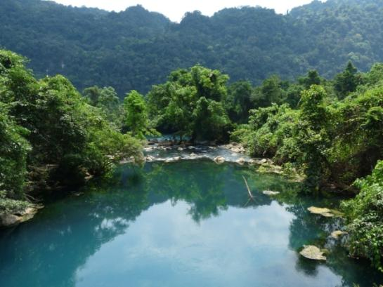

Strategic Management Plan
2013 to 2025
Phong Nha - Ke Bang National Park-World Heritage Site
----o0o----

A Report of the Nature Conservation and Natural Resource Sustainable Management in Phong Nha Ke Bang Region Project

Project director: Nguyen Trung Thuc

Project Chief Technical Advisor: Bas van Helvoort

-------------------------------------

Editor in Chief Luu Minh Thanh
Director of Phong Nha Ke Bang National Park

Compiled by: William V. Bleisch and Le Trong Trai and
contributions from Bas van Helvort &
Nguyen Van Tri Tin – AHT CO

Maps: Mai Ky Vinh and Nguyen Quang Quyet

Translator: Dang Thi Hoa

Editing laguages in Vietnames/English Nguyen Van Tri Tin

List of key contributors and participants in the planning process
Full name | Organization | Role
Mr. Luu Minh Thanh | Phong Nha - Ke Bang National Park | Director
Mr. Nguyen Van Huyen | Vice- director, PNKB National Park | Head of PNKB National Park Management Plan Working Team (MPWT)
Mr. Truong Thanh Khai | Head of Administration and Organization Department, PNKB National Park | PNKB NP MPWT member
Mr. Nguyen Van Hai | Head of Finance and Planning Department, PNKB NP | PNKB NP MPWT member
Mr. Nguyen Quang Vinh | Scientific Research and Rescue Centre (SRRC), PNKB NP | PNKB NP MPWT member
Mr. Nguyen Van Lan | Scientific Research and Rescue Centre (SRRC), PNKB NP | PNKB NP MPWT member
Mr. Le Chieu Nguyen | Eco-Tourist Centre, PNKB NP | PNKB NP MPWT member
Mr. Doan Thanh Binh | National Park Forest Protection Division, PNKB NP | PNKB NP MPWT member
Mr. Phan Hong Thai | Phong Nha - Ke Bang National Park | Director of PNKB Forest Protection Department
William V. Bleisch, Ph.D. | China Exploration & Research Society | Technical advisor for Management Planning
Mr. Le Trong Trai | Bird Life International | Technical advisor for Management Planning; Author of the Operational Management Plan for the PNKB National Park
Mr. Graeme Worboys, Ph.D. | IUCN World Commission on Protected Areas (WCPA) | Vice Chair Mountains Biome Theme, Technical advisor for World Heritage requirements
Mr. Bas van Helvoort, MSc. | PNKB Region Project (KfW Component) | Chief Technical Advisor
Mr. Nguyen Van Tri Tin, MSc. | PNKB Region Project (KfW Component) | Deputy Chief Technical Advisor
Mr. Arnoud Steeman | PNKB Region Project (KfW Component) | Former Chief Technical Advisor
Mrs. Pham Thi Lien, Hoa | PNKB Region Project (GIZ Component) | Advisor and project liaison
Mrs. Nguyen Ngoc Anh | PNKB Region Project (GIZ Component) | Advisor
Mr. Dang Dong Ha | Vice Director, Phong Nha - Ke Bang National Park | Head of the STDP Task Force Group
Mr. Le Van Lanh | National Park and Protected Areas Association of Vietnam | Co-author of the Sustainable Tourism Development Plan (STDP) for the PNKB NP Region
Mr. Dirk G. Euler | Project Manager, Primates Reintroduction Programme, Frankfurt Zoological Society | Advisor
Ms. Sladjana Miskovic | Project Manager, Kolner Zoo | Advisor
Mr. Achim Munz | Tourism Resource Consultants  New Zealand – TRC | Co-author of the STDP for the PNKB NP Region
Mr. Douglas Hainsworth | Tourism Resource Consultants  New Zealand – TRC | Co-author of the STDP for the PNKB NP Region
Mr Nguyen Quoc Dung | Vietnam FIPI | Compiler of the Buffer Zone Development Plan for the PNKB NP Region
Department of Environment and  Climate Change (New South Wales) | Compilers of the Greater Blue Mountains World Heritage Area Strategic Plan | Template and Background materials on World Heritage Sites

Unless otherwise credited, photos
WVBleisch/CERS for the PNKB National Park Region Project Management Unit

PROJECT SUPPORT

The Strategic Management Plan 2013 – 2025 for the Phong Nha - Ke Bang National Park Region was an output of the Nature Conservation and Sustainable Management of Natural Resources in the Phong Nha - Ke Bang Region Project and was prepared as a consultancy assignment for the Project Management Unit with the support of the KreditanstaltfürWiederaufbau (KfW). The project is funded by the BundesministeriumfürWirtschaftlicheZusammenarbeit und Entwicklung (BMZ).

The project is a joint cooperation between the Provincial Peoples’ Committee (PPC) of Quang Binh from the Vietnamese side and KreditanstaltfürWiederaufbau (KfW), GTZ, and DeutscherEntwicklungsdienst (DED) from the German side. The PPC is the executing agency and the Department of Planning and Investment (DPI) of the PPC acts as project owner and implementing body. GTZ and KfW support the project by means of financial and technical cooperation. A cooperation agreement between the PPC and GTZ was signed on 19th October 2007 and on the 23rd of January 2008 the agreement between the PPC and KfW was signed.

The overall objective of the project is to contribute to the conservation of the Central Annamite Region and its biodiversity and ecological services in close relation with a sustainable socio-economic development in the Core Zone (including Administration and Service Area, Ecological Restoration Area, and Strictly Protected Area, including the extension area) and Buffer Zone of the National Park. The project seeks to reduce the pressure on the natural resources of the National Park in part by support for the reorganising of legal income and alternative livelihood activities of the local population. The Project duration is eight years, six years for the implementation phase and the last two years for the aftercare phase.

The project prepared a Sustainable Tourism Development Plan for the PNKB NP Region in 2010 and it also supports the on-going preparation of a Buffer Zone Development Plan for the Buffer Zone of the National Park, and an Operational Management Plan for the National Park itself. This Strategic Management Plan is a comprehensive planning document that guides the development of all aspects of the region, integrating the intervention strategies and implementation programme of these other plans to achieve the objectives of the World Heritage.
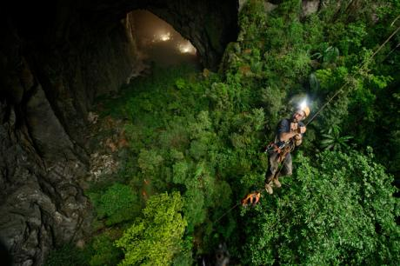
Doline inside Son Doong Cave. Photo: Carsten Peter through National Geographic.
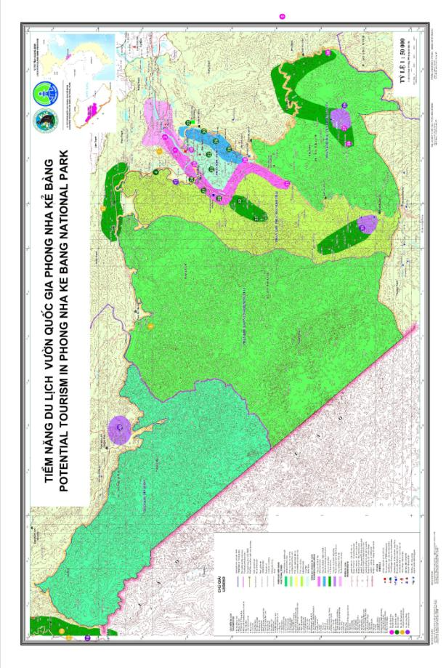

Letter dated 16 Feb. 2012 from the Quang Bihn Provincial People’s Committee to the PNKB National Park Management Board.
For more information, see http://whc.unesco.org/
WWF (2012) About the AnnamitesEcoregion.http://wwf.panda.org/what_we_do/where_we_work/project/projects_in_depth/greater_annamites_ecoregion/about_the_area/ Downloaded 18 August 2012.
This is the Overall World Heritage OUV Management Objective for Criterion (viii)
This would be the Overall World Heritage OUV Management Objective for Criterion (ix) and Criterion (x) when they are approved. It also overlaps with the first two Objectives for PhongNha-Ke Bang National Park as set out in Article 3 of the Decision of the Prime Minister dated 12 December 2001.
This was the result of key technical and financial support from Cologne Zoo and Frankfurt Zoological Society.
Operational Guidelines for World Heritage Sites (2011), Article 93. The following points refer to Articles 94 and 95.
This essential task will be carried out with the assistance of the Forestry Institute of Planning and Investment (FIPI), as per regulations. According to the Decision No 3013/1997/QD-BNNPTNT, the chapter 3 (implementation arrangement of demarcation) – article 12, “the forest area that have ownership then the forest owners conduct boundary define and demarcation in the field. This activity must … have participation of local authority government (commune/district), forest rangers/ FPD; land survey agency / DoNRE and other relevant agencies.”
For introduction to its application in protected area management, see United States National Park Service (2007) Summary: Climate Change Scenario planning workshop Joshua Tree National Park and Kaloko-Honkohau National Historical Park.
Pedersen, A. (2002) Managing Tourism at World Heritage Sites: a Practical Manual for World Heritage Site Managers, World Heritage Paper No. 1, UNESCO, World Heritage Centre, Paris 2002.
Interpretation, refers to the full range of potential activities intended to heighten public awareness and enhance understanding of a site. (UNESCO 2012 Managing World Heritage.)
According to Decree 24, expenditures shall be linked to each village’s forest protection plan and commitment. In the case that poor performance in forest protection is recognized in a certain village, the Management Board is allowed to shift the funding to another village.
Operational Guidelines for World Heritage Sites (2011), Article 119
In line with Decision 24, this process is a mechanism for village members to be directly involved in planning for village investments contributed by the Park and the Project. This is necessary so that the solutions supported will be appropriate for local livelihoods, conditions and customs.
See Appleton, M. R., Texon, G.I. &Uriarte, M.T. (2003) Competence Standards for Protected Area Jobs in South East Asia. ASEAN Regional Centre for Biodiversity Conservation, Los Baños, Philippines. 104pp.http://mekongtourism.org/website/wp-content/uploads/downloads/2011/02/ASEAN-Competence-Standards-for-Staff-Working-in-Protected-Area.pdf
The task of demarcation is generally out-sources to experts from the Forest Inventory and Planning Institute, and so no training is recommended here.
Hockings, M., Stolton, S., Leverington, F., Dudley, N. and Courrau, J. (2006) Evaluating Effectiveness: A framework for assessing management of protected areas, (2nd edn) World Commission on Protected Areas, IUCN; Gland, Switzerland.http://data.iucn.org/dbtw-wpd/edocs/PAG-014.pdf
The Park’s Centre for Scientific Research, which manages a botanical garden and wildlife rescue centre, may be a foundation on which to develop and implement a collaborative, interdisciplinary and strategic approach to research and education in the region.
WWF (2012) About the Annamites Ecoregion. http://wwf.panda.org/what_we_do/where_we_work/project/projects_in_depth/greater_annamites_ecoregion/about_the_area/ Downloaded 18 August 2012.
pp. 223-224 in EJ Sterling, MM Hurley, Le Duc Minh (2006) Vietnam: A Natural History. Yale University Press; New Haven.
It has been suggested that the Quang Binh PPC should define a special process for any developments (including Park operations) that may impact the PNKB World Heritage Property, as part of the EIA decision-making process. This process would include identification of the types of developments or proposals that are subject to a special EIA or SEIA. For example, a lease for a tourism development or a tourism service in the National Park would be subject to a special EIA, while a regional development plan would be subject to a special SEIA. The EIA or SEIA must describe the World Heritage Outstanding Universal Value that might be impacted and the measures to minimise any impact. Process steps to consider are: 1. Identification that the proposed development or activity is consistent with the World Heritage Convention and the National Park Management Plan; 2. Opportunity for review and input by outside independent parties, such as the national UNESCO World Heritage office; 3. Process sign-off by the Director of the National Park, assuring that the World Heritage values will not be significantly impacted.
Based on R. Webb (2012) Cave Mangement Prescription: An alternative to Cave Classification Systems.http://www.ackma.org/papers/cmprescriptions.html
The Union Internationale de Speleologie (UIS) and IUCN in 2012 cooperated to produce Management Guidelines for Show Caves that should be referred to for management of any caves that are to be developed as show caves. http://www.karstportal.org/sites/karstportal.org/files/Recommended_Management_for%20_Show_Caves.pdf
Apel, U., Maxwell, O.C., Nguyen Trong Ninh, Nurse, M., Puri, R.K. and Trieu Van Co (2002) Collaborative Management and Conservation: A Strategy for Community Based Natural Resource Management of Special Use Forest in Vietnam. Fauna & Flora International/World Bank; Cambridge, UK. (Summary in Vietnamese).
These were called Biodiversity Conservation and Development Contracts under the Pu Luong Nature Reserve. The name proposed here may be more familiar, and corresponds to the wording in Decision 24.
See Appleton, M. R., Texon, G.I. &Uriarte, M.T. (2003) Competence Standards for Protected Area Jobs in South East Asia. ASEAN Regional Centre for Biodiversity Conservation, Los Baños, Philippines. 104pp.http://mekongtourism.org/website/wp-content/uploads/downloads/2011/02/ASEAN-Competence-Standards-for-Staff-Working-in-Protected-Area.pdf
Biodiversity and Protected Areas Management Project(BPAMP) (2006) Ranger-Based Data Collection, A Reference Guide and Training Manual for Protected Area Staff in Cambodia. Department of Nature Conservation and Protection, Ministry of Environment, Cambodia

